Electrical Installation & Estimating (Th- 01)

Sixth Semester
Electrical Engg.

ELECTRICAL INSTALATION & ESTIMATING

CH- NO | TOPICS | EXPECTED MARKS
01 | I.E RULES & STANDARDS | 10
02 | ELECTRICAL INSTALLATION | 20
03 | INTERNAL WIRING | 15
04 | OVER HEAD INSTALLATION (H.T & L.T) | 20
05 | OVER HEAD SERVICE CONNECTION (1 ɸ& 3ɸ) | 20
06 | ESTMATE FOR DISTRIBUTION SUBSTATION | 15

CH-1

I.E RULES AND STANDARDS

ESTIMATING---

It is defind as an at accessment of different items and their cost as per the plan which are required for executing a work before actually done.
Following words have their specific meaning according to the Indian electricity rules 1- Amper-
- It is the unit of current
- -in other words it is the unvaring electric current which when passed through a solution of nitrate of silver in the water, it deposites silver at the rate of 0.01118 gm/s
- volt-
  - it is the unit of voltage or E.M.F
  - it is also defind as an 1 volt of electric potential which when apply steadily to a conducter containing 1 ohm resistance will flow or cause to flow 1 amp of current.
- Circuit-
  - It is the defind as a closed path along which the electric current can flow.
- Circuit breaker-
  - It is defind as a device which is capable of making and breaking the circuit under all condition.
- Switch-
  - It is defind as a manually operate device for closing and opening of an ele ctrical ckt.
- Cut out-
  - It is defind as an appliance which is capable of automatically interrupting the electrical energy through any conductor when the current rises above the pre-determined amount.
- Conductor-
-it is defind as an material which conducts the electrical energy or currents when connected with an electrical system.

- live

It is defind as something which electrically charged.

- Dead

It is defind as something which is disconnected from any live system and it must have the potential equal to the earth potential.

- Span

The horizontal distance between the two adjacent of consucative support is called as span.

- danger

It is defind as any injury to person or property or fire explosion of burning or any part of the body from electric shock or injury to life due to generation ,transmission , distribution & utilization of electric power of energy

- earthing system-

  - It is defind as a system in which all the appliances are properly earth.

- system-

It is defind as an electrical arrangement in which all the conductor s or apparatus are connected electrically to a common source of supply.

- apparatus-

It is defind as an electrical equipements which includes all accessories m/c fitting & appliance where conductor are used.

- bare-

It is defind as something which is not covered with any insulating materials 16- conduit-
It defind as a tubular structure may be of rigid or flexible which is mechanically strong and fire proof through which cables are drawn.

- cable-

It is defind as a length of insulating single or more conductors which are aid up together.

- Electrician-

It is defind as a person over 21 years of age & is competent for all the I.E rules in which ,he is assign to his work & who has ben appointend by the agent or manager of the installation.

19 -voltage

It means th difference of electrical potential mesurred in volts between any part of the conductor & the earth as measured by a suitable voltmeter.

- Low voltage-

According to I.E rules it is defnd as a voltge which does not exceeds 250v under normal condition subjected to the percentage of variation allowed by the rules.

- medium voltage-

According to I.E rules ,it is defind as a voltage ranging from250v to 650 v under normal conditions subjected to the % of the variation allowed by the rules,

- high voltage –

According to I.E r ule it is deind as 650 vto the33000 v under normal condition allowed by the

rules.

- extra high voltage according to i.E rules it is defined as the voltage which exceeds above 33kv under normal condition subjected to the percentage of variation allowed by the rule.

The maximum voltage regulation allowed for low voltage and medium voltage is +/- 5% as per I.E rules.

The maximum voltage regulation allowed for high voltage and extra high voltage is +/-12.5% as per IE rules.

GENERAL SAFETY PRECAUTION-

Rule-29- construction ,installation ,protection ,operation & maintenance of of electric supply lines & apparatus-

-All electric supply lines & apparatus shall be constructed, installed ,protected ,worked ,& maintained in accordance with standards for the I.E rule so as to prevent danger

Rule-30- service lines and apparatus on consumer’s premises

-the supplier shall ensure that all electric supply lines ,wires, fittings & apparatus belonging to
him or under his control which are on a consumer’s premises are in a safe condition.

Rule-31- cut-out consumer’s premises

-the supplier shall provide a suitable cut-out in each conductor of every line

-such cut-out shall be contained within adequately enclosed fire –proof receptacle.

-the owner of every electric supply line shall protect it by suitable cut-out.

Rule-32- identification of earthed & earthed neutral conductor & position of switches & cut-outs therein

An indication of a permanent nature shall be provided by the owner of the earthed or earthed neutral conductor, such indication shall be provided.

Rule-33- Earthed terminal on consumer’s premises-

The supplier shall provide & maintain on the consumer’s premises use a suitable earthed terminal in an accessible position at or near the point of commencement of supply as defined under rule 58

-the consumer shall take all reasonable precaution to prevent mechanical damage

- it also prevent electrical shuck & machinery damage Rule-34 –Accessibility of bare conductor-
Where bare conductor s are used in a building the owner of such conductors shall –

  - Ensure that they are inaccessible
  - Take such other safty measure as are considered necessary by the inspector.

Rule-35- caution notice-

The owner of every medium. High ,extra high voltage installation shall affix permanently in a conspicuous position a caution notice in hindi or local language of district approved by inspector .

Rule-36- Handling of electric supply lines apparatus

Before any conductor or apparatus is handling ,the precautions shall be taken by earthing to discharge electrically.

  - No person shall work on any live electric supply line or apparatus
  - Takes the safty measures approved by inspector.

Rule- 40 Street box-

Precautions shall be taken to prevent ,as far as reasonably possibly, say influx of water or gas.

  - All owner have to installed street box for prevention of danger from sparking
  - All street box shall be regularly inspected for the purpose of detecting the presence of gas.

Rule-41 distinction of circuit of different voltage.

-to easy control in substation or power grid Rule-43- provisions applicable to protective equipment-
  - Fire buckets filled with clean dry sand and ready for immediate use for extinguishing fires

  - First aid boxes must be installed

Rule-44 Instructions for restoration of persons suffering from electric shock-

  - It shall be affixed by the owner in a conspicuous place in every generating station.

Rule-49-leakage on consumer’s premises

If the inspector or the suppliers has reason to believe that there is in the system of consumer leakage which is likely to affect injuriously the use of energy by te supplier or by other person ,which is likely to cause danger he may give the consumer reasonable notice in writing that he desire to inspect & test the consumers installation.

Rule-50-supply to consumers –

Necessary all kinds of apparatus ,safty device to supplied consumer followed by I.E rules Rule-51-provisions applicable to medium, high or extra high voltage installations
  - All conductors shall be completely enclosed in mechanically strong metal casing
  - All metal work enclosing ,supporting or associated with the installation
  - Every main switch –board shall a clear space of not less than 3 feet in width shall be provided in front of the switch board.

Rule-54-declared voltage of supply to consumer.

For 1-ɸ- 240v

For 3-ɸ -440v, 11kv, 33kv etc

Rule-55-declared frequency of supply to consumer Rule-56- sealing of meters and cut-outs-
A supplier may affix one or more seals to any cut-out & to any meter ,maximum demand indicator, or other apparatus placed upon a consumers premises

Rule-57-meters,maximum demand indicators and other apparatus on consumer’s premises- No meter shall register at no load
Every supplier shall examine , test & regulate all meter , maximum demand & other apparatus Rule-58-piont of commencement of supply
Rule-59-precautions against failure of supply:

notice of failure- the supplier shall take all responsible precaution to avoid any accidental interruption of supply & also to avoid danger to the public

Rule-60-test for the resistance of insulation-

All insulators are to be insulation test which provision for electric supply , Rule-61-connection with earth
Prevention of electric shock & damaging of apparatus required Rule-62-system at medium voltage
Where a medium voltage supply system is employed the voltage between earth & any conductor forming part of the said system shall not , under normal condition ,exceed low voltage.

Rule-63-approval by the inspector

Before installing high & extra high supply ,the consumer have to take permission of inspector

Rule-64-use of energy at high and extra-high voltage-

The inspector shall not authorize a supplier to connect a supply of energy at high or extra high voltage to any consumer unless I.E rules

Rule-65-voltage tests

Rule-66-metal sheathed electric supply lines

Provision for precaution against excess leakage.

Rule-68-general conditions as to transformation and control of energy.

Energy is transferred & converted by substation & switch station.

Substation& switch station ‘shall be perfectly be erected above ground but where necessary
constructed underground , provision for ventilation & drainage shall be made. Rule-70-condensers-
Suitable provision shall be made for immediate & automatic discharge of every static condenser on disconnection of supply

Rule-74-joints

Joints of conductors in over head line must be mechanically strong.

Rule-75-maximum stresses : factor of safety

  - for metal supports
  - for mechanically processed concrete supports
  - for hand moulding concrete supports
  - for wood supports

Rule-76-clearances above ground of the lowest conductor

  - no conductor of an over head line , including service lines, erected across a street shall at any part there of be at height less than-
    - for low or medium voltage 19 ft
b) for high-------------------- 20ft
  - along any street
    - For low or medium 18 ft
    - For high -19ft
  - For extra high voltage lines the clearance above ground shall not less than 17 ft Rule-77-clearance between conductors and trolley wires
- No conductor of an over head line crossing a tramway or trolley bus route using trolle wires shall have less than the following clearance above any trolley wire.
  - Low & high voltage 4ft
  - For insulated covered conductor 2ft
  - high voltage upto 11kv 6ft
  - above 11kv 8ft
  - extra high vlatge 10ft

Rule-78-clearances from buildings of low and medium voltage lines and service lines

  - when the line passes above the building , a vertical clearance of 8 ft from the highest point
  - adjacent to the building , horizontal clearance of 4 ft

Rule-79-clearance from buildings of high and extra-high voltage lines

- Vertical clearance above the highest part of the building immeadiatly under such lines of not less than
  - For high voltage upto 33 kv 12 ft
  - For extra high – plus 1 ft for every additional 33kv
- Horizontal clearance between the nearest conductor & nearest any part of building.

  - Upto 11kv- 4ft
  - 11kv—to--- 33kv 6ft
  - For extra high ft & plus 1ft for additional 33kv

Rule-80-conductors at different voltages on same supports’

Where conductors forming at different voltages are erected on the same supports the owner shall make adequate provision to guard. Clearance between the different conductors voltage shall be subject to the prier approval of the inspector.

Rule-86-lines crossing or approaching each other –

Where an over head line crosses other over head line ,then guard must be used Rule-87- guarding
Line crossing over head line guard must be required.

Rule-88-service lines from overhead lines-

No service line or lapping shall be taken off from an over head line except at apoint Rule-89- Earthing
All metal supports of over head lines & metallic fittings attached thereto ,shall be permanently & efficientlyearthed

Rule-90-safety and protective devices

Every over head line erected over any part street or other public place on any consumers premise.

Rule-91-protection against lightning

For protection against lighting , the lighting arrester is used

Short question and answer-

- write the following terms as per Indian Electric Rules?

Q.1-low voltage
Ans- according to I.E rules it is defind as a voltage which doesnot exceeds 250 v under normal condition .

Q.2-High voltage
Ans- according to I.E. rules it is defined as a voltage ranging from 650v to 33,000v or 33kv under normal conditions subjected to the percentage of variation allowed by the rules.
Q.3-Extra high voltage
Ans –it is defined as a voltage which exceeds above 33kv under normal condition. Q.4-Medium voltage
Ans –according to I.E. rules it is defined as an voltage which ranging from 250v to 650v under normal conditions subjected to the percentage.
Q.5-Ampere
Ans- it is the unit of current
In other word it is the un varying electric current which when passed through a solution of nitrate & silver in water, it is deposited the silver at the rate of 0.001118gm/sec
6-Circuit Breaker
Ans-it is defind asdevice which capable of making & breaking the ckt under all condition 7-Cutout
Ans- it is defind as an appliances which is capable of automatically intrupting the electrical energy through any conductor when the current rises above the pre determined amout.
8-Live
Ans- it is defind as something which is electrically charged 9-Dead
Ans it is defind as something which is disconnected form any live system & it must have the potential equal to the earth potential
10-Earthing system

Ans- it is defind as the system in which all the appliances are properly earthed 11-Span
Ans- the horizontal dintaces between the two consucative supports is called as span 12-Bare

Ans -it is defind as something which is not coverd with any insulating materials

CH-4

OVER HEAD INSTALLATION

Over head installation(H.T)

DISTRIBUTION-

Generally for distributing for electrical energy we have two types of system such as L.T distribution and H.T. distribution. It depends on the voltage to supply.

It may be HT & LT distribution but the following accessories must be used in the over head distribution system
Supports-

Usually electric pole or towers are called as supports . the main function is to supports the conductor so as to keep it of a suitable lable above the ground .

-generally for LT distribution we used 8m or 9m PCC (pre-stress cement concrete ) or RCC (rein forced cement concrete) and also rein pole of 9m & 10m height.

Similarly for HT distribution we used 9m PCC or RCC pole & rein forced of height 12 m.

-depending on the voltage will supply & variation regions. We also used tower for HT distribution.

- factors governing height of the pole –

Followings are the important factor governing the height of the pole.

  - the minimum clearances of the lowest conducter form the ground.
  - the number of conducter to be carried out and minimum vertical clearances between the conducter.
  - the length of pole to be borried in the ground(generally1/6th of total height of the pole) must be borried in the ground in normal soil.

CROSS ARM – It is a cross picotited to the pole top at the end portion by means of brackets known as pole brackets such cross arm are use to hold the insulation in a suitable picing

Generally in the distribution line we use m/s channel, angle iron, U- shaped , V-shaped or zizzaz shape cross arms are used.

  - Pole bracket & clamps- generally pole brackets are used to hold the cross arms wih the poles.
The brackets may be of the channels or angle iron and may be of pipe brackets.

-clamps are made up off flat iron & are used for fixing as well as holding survice line, stay wire, earth wire, shackle Insulators and cross arms etc.

INSULATOR -

-The main function of the insulator in distribution line is to avoid the direct contact of the charged conductor with the earth.
-the commonly used material for the over head line insulator is porceline , toughed glass & ceramics.
- we have the following types of insulators. 1-pin type insulator-
This type of insulators are generally used in 240V, 440V, 11KV & 33KV. 2-Disc insulator are of two tpes depending upon its uses
i-suspension insulator ii-strain insulator
i-SUSPENSION INSULATOR-
if the disc insulator are arranged in vertically then it is called as suspension insulator. ii-STRAIN INSULATOR-
If the disc insulator is arranged in horizontally then it is called as strain insulator.
-Generally disc insulators are used 11KV unwards. 3-SHACKLE INSULATOR-
This insulator is used only in LT line in 440V at the tapping pole, dead end pole and deviation pole.
-this insulator is also used in street light purpose. 4-EGG INSULATOR-
The insulator which is used in stay wire L.T. line as well as H.T. line is called as egg insulator . Its appearance is similar to egg.
Conductor—
In distribution line conductor plays a vital role to transmit or circutate the electric current . hence conductor is a medium of electric supply system.
-generally we use AAC (All Aluminium conductor ) & ACSR ( Aluminium conductor steel reinforced) as the over head conductor in the distribution l ine.

While stretching the conductor we must have to maintain a specific clearance a mong the conductors is called as conductor spacing and also between the ground called as ground clearance.

a general formula is used to get the conductor spacing SPacing =√𝑠 ×(v/150)
Where ,S= Sag of the conductor

V = Line voltage ,V

Supply voltage in  (kv) | 0.4 | 11 | 33 | 66 | 132 | 220 | 400
spacing | 0.2 | 1.2 | 2.0 | 2.5 | 3.5 | 6.0 | 11.5

Similarly the ground clearance of the conductor in different locations are mentioned below.
Supplied voltage in  (kv) | 0.4 | 11 | 33 | 66 | 132 | 220 | 400
Across  street (m) | 5.8 | 5.8 | 6.1 | 6.1 | 6.1 | 7.0 | 8.4
Along  street (m) | 5.5 | 5.5 | 5.8 | 6.1 | 6.1 | 7.0 | 8.4
Other  areas | 4.6 | 4.6 | 5.5 | 5.5 | 6.1 | 7.0 | 8.4

Span length :-Depending on the supplied voltage of the distribution line as Well as transmission line we have following spans for the various types of supports.

- wooden pole span is 40m to 50m. (2)steel tubular pole span is 50m to 80m.
(3) RCC and PCC pole span is 50m 200m. (4)steel towers span is 200m to 400m.
For river crossing long spans about 800m may be consider which is exceptional.

LIGHTING ARRESTER –
It is device which protects all the electrical equipments from damage due to surge Voltage of lighting. Hence all the over head conductors are also connected lighting
arrester at the substations, greeds etc. similarly all the modern protective devices must be connected with this lighting arrester.

PHAGE PLATE-

To identify the colour code of over head conductors such as red (R), yellow (Y), & blue(B) such Phase plates are attached with the supports .
DANGER PLATE –usually this plate is placed at a height of 2.4m from the ground on the support. This plate contains supplied voltage which is written in English hindi & in local language.

This plate is used aware the human being. ANTI –CLIMBING WIRE-
This wire is provided around the poles at a height of about 2.5 m from the ground for atleast
1m.

-it is use not to climb any unauthorized person. BIRD GUARD-
These are the wooden pieces of size about 10cm *12.5cm*15cm ,in case of metal poles are fitted under the insulators.

-bird guards are used to avoid the short ckt or earth fault due to sitting of birds which may short ckt live conductors or any one line conductor with earth.

JUMPER-

Jumper the conductors which are used to continuity supply line from one point to another point by jumpering.

  - Jumpers are generally used In DP structure & where disconnection of supply line is exiting.

GUARD WIRE-

it is the used to protect the live of the human being as well as wild life .

  - These are used in the place or location of road crossing , over the telephone line railway crossing etc.

STAY-

Stay is basically used to provide support to the line poles where they are un balance irrection.

  - Generally stay is done at an angle 45 degree or not less than 30 degree.
  - For HT line this stay angle may vary from 45 degree to 60 degree.

Problem-1

Electric supply to a factory is to be taken from an existing 11kv overhead 3-phase line for a distance of 1km from the exiting line. If this line is meaned for 300A load prepare a list of materials required for this purpose .assume a road crossing in this distribution line.

Solution-

1)-Calculation for no of poles- Toatal length of line =1km=1000m

Assume that span length =50m So no of span =1000/50=20
So no of poles required =20+1=21

As road crossing are their this line ,so one more pole is required for this purpose. Hence total no of poles required =21+1=22
2)- single line diagram
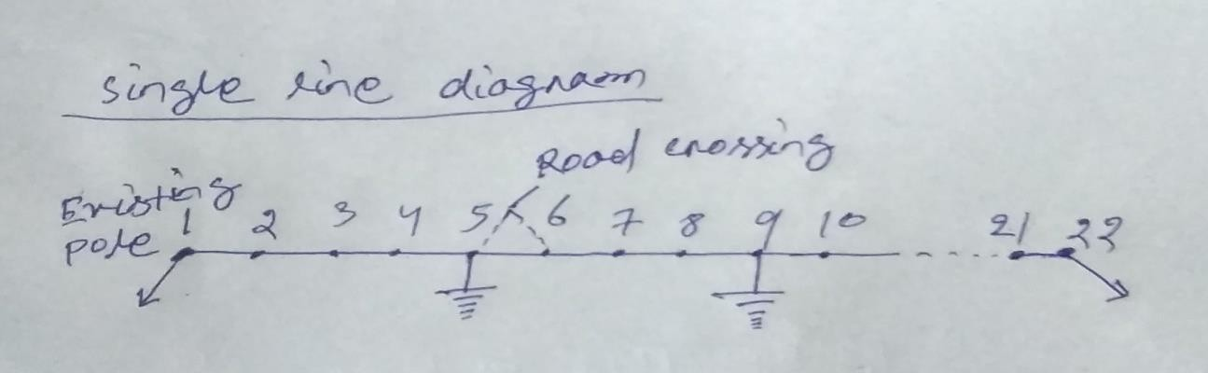

Calculation for no. of cross arm:- According to single line diagram , let us select angle iron cross arm at the taping pole as well as dead end pole & rest of the intermediate poles we select ‘v’ cross arm.

So no of angle iron cross arm required =2

So no of ‘V’ cross arm required =2

- calculation for no of insulators-

According to the above line diagram strain insulators are used at the tapping poles as well as dead end pole .11 KV pin insulators are used in rest of the intermediate poles.

Hence no of disc insulator required = 3+3=6 Total no of 11kv pin insulators =21*3=63
5)- calculation length of over head conductor

Net length of conductor required =3*(total length of the line +2% for sag)=3*(1000+20) =3060 m Considering 12m extra for twisting & binding at the tapping pole as well as dead end pole.
So gross length of conductor =3060+12=3072 m 6)- selection of overhead conductor-

From the conductor table for the current rating of 305A at 40⁰c ACSR , 6/1 × 4.50 , caf type conductor should be selected.

Material table-

SI | DESCRIPTION | SPECIFICATION | QUANTITY
01 | Supports | RCC, 9m | 22 nos
02 | Cross arms with it’s fitting accessories | - angle iron cross arm  - V- cross arm | 2 nos  21 nos
03 | Insulators with its fitting accessories | - disc type 11 kv  - pin type 11 kv | 06 nos  63 nos
04 | Over head conductor | ACSR , 6/1 × 4.50mm cat type | 3072 m
05 | Stay with its fitting accessories | For11 kv line | 02 set
06 | Earthing with its fitting accessories | For 11 kv | 04 set
07 | Angle iron cross arm to support the guerd wire | 100mm*50mm*7.5 mm long ,MS type | 02 no
08 | Guard wire | 14 SWG ,GI | 50m
09 | Binding wire at the rate 100gm per pin insulator | Alluminium type ,single core | 6300=6.3kg
10 | Anti climbing wire at the rate 3m per pole | G.I type | 66m
11 | Danger plate | 11kv | 22 nos
12 | Complete the whole job |  | As per required

Q-1 prepare the list of materials required for a stay set & also draw neat sketch

.
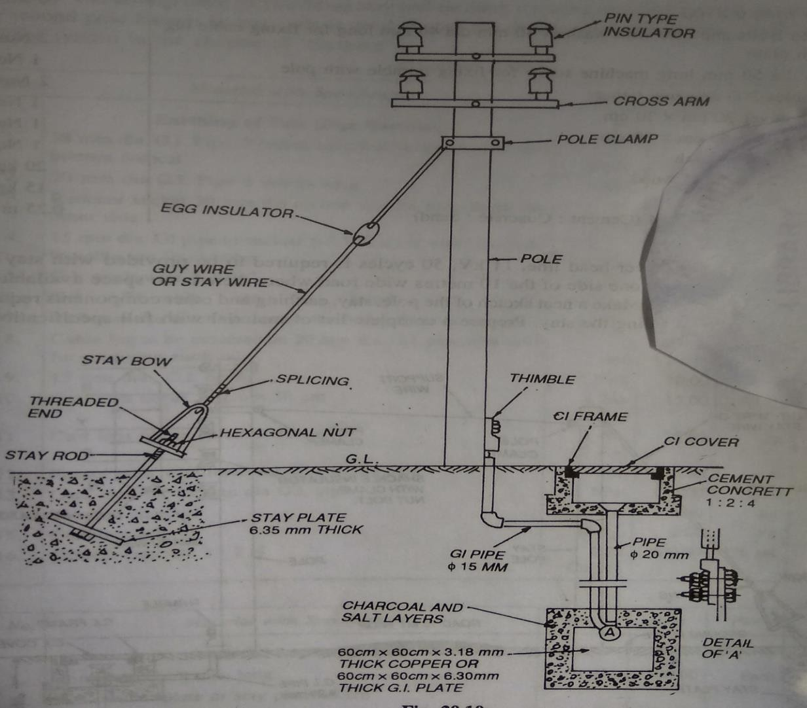

Material table-

Si | Description | specification | Quanity
01 | Anchor plate | (45*45*6.0) cm M.S  type | 01 no
02 | Stay rod | M.S type 16mm dia,  2.42m lng | 01 nos
03 | Stay bow | M.S type 12mm dia | 01 nos
04 | Stay wire | 7/8 SWG ,G.I | 7.5m
05 | Stay isulator | Porcelien type | 01 no
06 | Stay clamp or pole clamp | -- | 01 no
07 | Nut bolt | 16mm dia, | 02 nos
08 | Stay thimble | M.S type | 02 nos
09 | Sun dries to complete the whole job | ------ | As per required

Q-2- prepare the list of materials required for pipe earthing and also draw the neat sketch

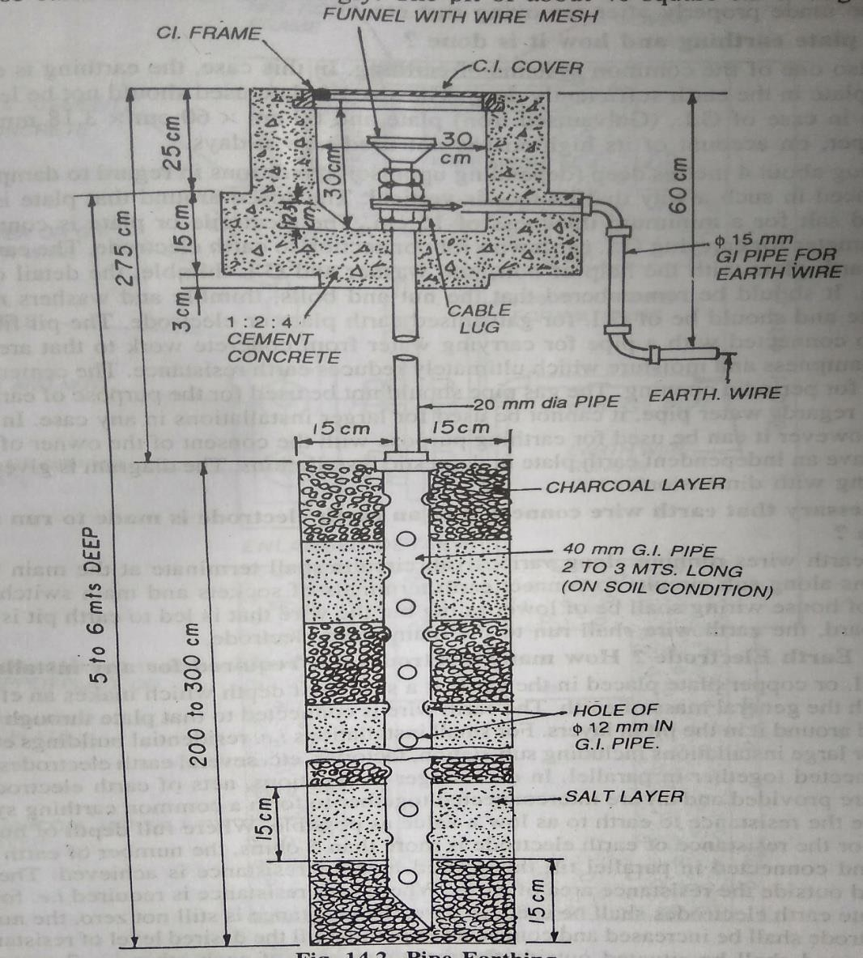

Material table

Si no | Description | specification | Quanity
01 | G.I pipe | 38mm dia,2.5 m long | 01 no
02 | G.I pipe for watering | 19mm dia,1.5m long | 01 no
03 | G.I pipe | 13mm dia ,4.5m long | 01 no
04 | G.I wire | 6SWG | 12m
05 | G.I lugs | G.I type | 02 nos
06 | G.I nut bolt | 10 mm dia ,16mm dia | 04 nos
07 | G.I bends | 13mm dia | 02 nos
08 | Cast iron frame | 30cm *30 cm | 01 no
09 | Cast iron cover | 30 cm * 30 cm | 01 no
10 | Funnel | - | 01 no
11 | Channel | - | 10kg
12 | ¤ Common salt | - | 10kg
13 | Sundries to complete the whole job | - | As per required

Problem-04-

Prepare an estimate for high tension line for a distance of 5km using ACSR conducter to transmit 400kw load at 0.85 p.f. in 3-phase 11kv line, the span is 100m, and also draw the neat sketch.
Solution:- (1)Calculation for no. of poles:- Total length of line=5km =5000m
Given that span length =100m No. of span =5000/100 =50m No of poles required =50+1=51

- single line diagram :-

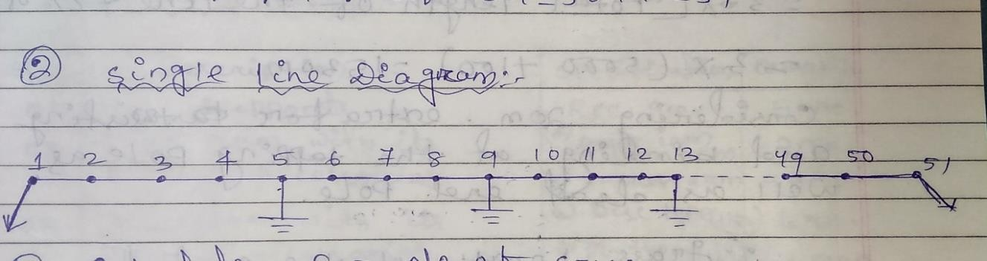

- calculation for no. of cross arms;-

according to single line diagram let us select angle iron cross arm at the tapping pole as well as
dead end pole and rest of the intermediate poles we select ‘v’ cross arm.

Hence,

Total no. of angle iron cross arm required =2 no. Total no. of v cross arm required =49 no.
Calculation length for no of insulator :-

According to the above line diagram strain insulator are used at the tapping pole as well as dead end pole . 11kv pin insulator are used in rest of the intermediate poles.

Hence ,

No. of disc insulator required =3+3 =6

No. of 11kv pin insulator required 49×3 =147 no.

Calculation length of over head conductor :-

Net length of conductor required =3×[total length of the line +2% of sag ]

=3×(5000+100) = 1530 m

Considering 20m extra for twisting and binding at the tapping pole as well as dead end pole.

Grass length of the conductor = 15300+20 =15320m Select ion of over head conductor :-

Here, given that

P= 400kw =400×10³w

Cosɸ =0.85

VL =11kv =11×10³ v

We know that ,

P=√3 VL I L cosd

- I L = P/ √3 VL IL cosd

= 400×10³/√3×11×10³×0.85=24.69 A
Full load current , IFL= 24.69 A Short –cut current , ISC = 1.5 ×IFL
=1.5 ×24.69

=37.035 A

According to the S.C. current from the conductor table we should select 6/1×2.11 Squirrel type ACSR conductor.

Material table :-

Si no | Description | Specification | Quantity
01 | Supports | RCC 9m | 51 nos
02 | Cross arm with its fitting accessories | - angle iron cross arm  - V-cross arm | 02 nos  49 nos
03 | Insulator with its fitting accessories | - disc type (11kv)  - pin type (1kv) | 06 nos  147 nos
04 | Over head conductor | ACSR 6/1×2.11 squirrel type | 15320m
05 | Earthing with its fitting accessories | For 11kv | 10 sets
06 | Stay set with its fitting accessories | For 11kvline | 02 set
07 | Binding wire at the rate 100gm per pin  insulator | Alluminium type songle core | 100*147  =14.7 kg
08 | Anticlimbing wire at the rate 3m per  pole | G.i type | 51*3=153m
09 | Danger plate | 11kv | 51 nos
10 | Sundries to complete the whole job | -- | As per  required

Problem-05 :-

An over head 11kv ,50 Hz ,3-d line is be tapped up for the existing 11kv line pole at about 90° angle. the purposed line has to be erected on 10m long RCC poles with ACSR conductor of size 6/1×2.11mm with average span of 100m line will have to pass through the city axis about ½ km long make a list of materials required for 3.2 km long.

Sol^{n} :- (i) calculation for no. of poles :-

Total length of line 3.2 km =3200m. given that span length =100m. no. of span =3200/100 =32 no.

No.of pole required 32+1 =33 no.

Line will have to passed through the city area so road crossing are there in this line so I more pole required for this purpose.

Total pole required 33+1 =34 no.

- single line diagram :-
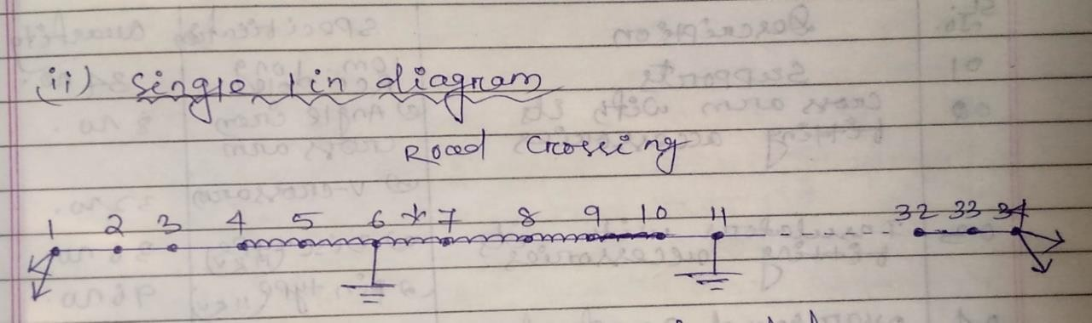

- calculation for no of insulators :-

According to line diagram 11kv strain insulator or disc insulator are used at the tapping pole as well as dead end pole and 11kv pin insulator are used in rest of intermediate pole.

No. of 11kv disc insulator required

3+3+30 =36 no.

No. of 11kv pin insulator required =96 no.

Calculation length of over head conductor :- Net length of conductor required
= 3×[total length of the line + 2% for sag]

=3×[ 3200+64] =9792 m.

Considering 50m extra for twisting and binding at the tapping pole as well as dead end pole. Gross length of the conductor
9792+50 =9842 m.

Material table :-

Si  no | Description | specification | Quantity
01 | Supports | 10m-long RCC pole | 34 nos
02 | Cross arm with its fitting accessories | - angle iron cross arm  - V-CROSS ARM | 8 nos  32 nos
03 | Insulator with its fitting accessories | - Disc type(11kv)  - pin type (11kv) | 36nos  96nos
04 | Over head conductor | ACSR , 6/1×2.11 mm | 9842 m
05 | Earthing with its fitting accessories | For 11kv | 5 sets
06 | Stay set with its fitting accessories | For 11 kv line | 4 sets
07 | Guard wire | 14 SWG G.I | 500m
08 | Binding wire at the rate log per pin insulator | Alluminium type single core | 100*96=9.6  kg
09 | Anti climbing wire at the rate 3m per pole | G.I type | 3*34=102m
10 | Danger plate | 11kv | 34 nos
11 | Sundries to complete the whole job | ---- | As per  required

over head installation (L.T)

Problem :-1

A 1km long over head distribution line of 415 v,50 Hz is to be erected along a straight root from 100kv A 11/0.4 KV pole mounting substation , the line is to be laid with 6/1×3.00mm ACSR conductor with 9m RCC pole . make a list of materials required and assume span length is 50m and also draw a rough sketch of this line.

Solution:- calculation for no. of poles :- Total length of line 1km =1000m. Given that span length=50m
No. of span =1000/50 =20 no.

No. of poles required =20+1 =21no.

Single line diagram :-

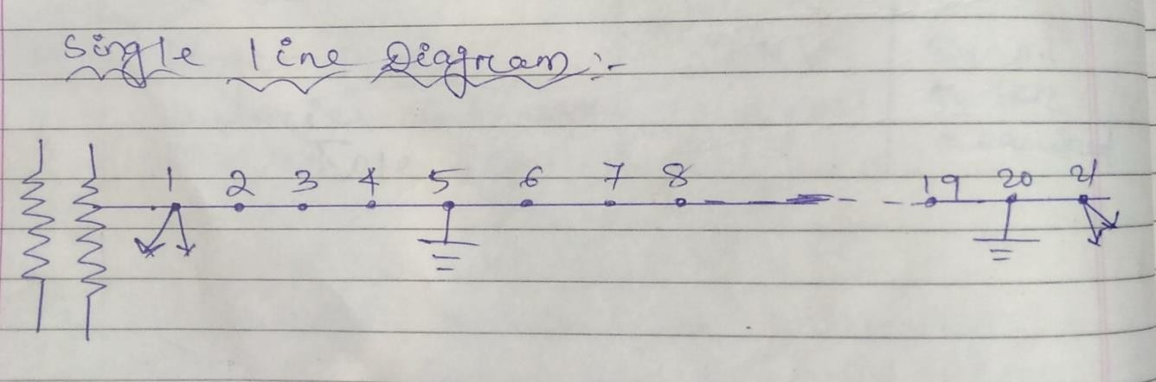

Calculation for no. of cross arm :-

According to the above single line diagram let us angle iron cross arm in each pole and one more cross arm required for tapping the line from the substation .

Hence, total no. of cross arm required 21+1=22

Calculation for no. of insulators :-

According to the single line diagram let us select shackle insulator at the tapping pole as well as dead end and rest of the intermediate poles we should select 440V pin type insulator.

Hence , no. of shackle insulators required =4+4=8 no.

Total no. of pin insulator required = 20 ×4 =80 no.

Calculation for length of over head conductor :- Net, length of the conductor
=4×[total length of the line +2% for sag]

=4[1000+20] =4080m.

Considering 20m. extra for twisting and cutting and binding at the tapping pole as well as dead end pole,

Hence , grass length of the conductor =4080+20 =4100m.

Material table :-

Si no | Description | specification | Quantity
01 | Supports | RCC, 9m | 21 nos
02 | Cross arm with its fitting accessories | Angle iron cross arm | 22 nos
03 | Insulator with its fitting accessories | Shackle insulator  Pin type insulator | 08 nos  08 nos
04 | Over head conductor | ACSR, 6.1×3.00mm long | 4100m
05 | Stay with its fitting accessories | For 440 v lines | 4 sets
06 | Earthing with its fitting accessories | For 440 v | 4 sets
07 | Binding wire at the rate 100gm/pin  insulator | Alluminiumsingle core | 8 kg
08 | Anti climbing wire at the rate 3m /pole | G.I type | 3*21=63 m
09 | Danger plate | 440v | 21 nos
10 | L.T cable | Pvc insulated aluminium core | 3 m
11 | Sundries to complee whole job | ------ | As per  required

Problem -2

An over head distribution line of 415 V , 3-d, 50Hz is to be errected along a straight root. The length of the line 300m. and the end supports are terminal structures, the span is 50m make an sketch of the terminal showing the disposition of the conductor . the conductor on the line are as follows.

  - phase wire :-hard drawn bare copper wire no. of 4 SWG.

  - neutral &street light hard drawn bare copper conductor number for 8 SWG. Prepare the list of material required for this purpose.
Solution :-calculation number of supports :- The total length of the line =300m Here span length =50m
Number of span =300/50=6 no. Number of pole required =7 no.
Single line diagram :-
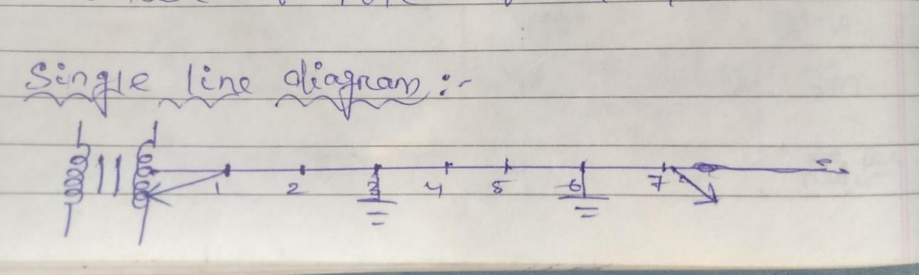

Calculation for no. of cross arm :-
according to single line diagram we should select angle iron cross arm in each pole and one more cross arm required for tapping the line from the substation .

Hence, total number of cross arm required =7+1 =8 no.

Calculation for no. of insulator :-

According to the questions three shackle insulators are required for 3-d other two shackle insulators required for street light and neutral for one pole .

Hence total no. of insulator required 8×5= 40 no.

Calculation for length of phase wire :-

Let length of the phase wire =3×(declared length +2% for sag)

=3×(300+6)

=918 m

Considering 15m extra for tuisting & cutting Gross length = 918+15= 933 m.
Calculation for length of neutral & street wire Length =2×[declared length +2% for sag ]
=2×[300 +6 ]=612 m.

Material table :-

Si no | Description | specification | Quantity
01 | Supports | RCC,9m | 7 nos
02 | Cross arms with its fitting accessories | Angle iron cross arm | 8 nos
03 | Insulator with fitting accessories | Shackle insulator | 40 nos
04 | Over head conductor( phase wire) | ACSR 6.1×2.00 mm | 933 m
05 | Over head conductor(neutral & street wire) | ACSR 6.1×3.00 mm | 612 m
06 | Stay set with its fitting accessories | 440 v line | 4 sets
07 | Earthing with its fitting accessories | 440v line | 4 sets
08 | Bindingwire at the rate 100gm /shackle  insulator | Aluminium type single  core | 100*40=4000gm  =4kg
09 | Anti climbing wire at the rate 3m/pole | G.I type | 3*7=21 nos
10 | Danger plate | 440v | 7 nos
11 | L.T cable | Pvc insulated 4 core  aluminium type | 3 m
12 | Sundries to complete the whole job | ------ | As per  required

Short question

- Write the various types of cross arm which are used in LT as well as HT. distribution ?
Ans :- the various types of cross arm using LT & HT distribution are angle iron cross arm & v-cross arm .
- What is the formula used for spacing of the conductor ?
Ans:- the formula use for spacing of the conductor is =√𝑆×V/150 Where , s=sag of the conductor
V= line voltage ,v
- What is the specification of stay wire?
Ans :- the specification of stay wire is 7/8 SWG G.I. type .
- Write the various type of insulators which are used in L.T. as well as A.T. distribution.
ans :- the various type of insulators which are used in L.T. as well as H.T. distribution are disc insulator, pin , shackle & egg insulators .
- what is vertical clearance of the conductor along the street and across the streets for supplying 11kv voltage ?
ans:- the vertical clearance of the conductor along the street is 5.5m and across the street is 5.8m for supply 11kv voltage .
- which type of insulators used in stay ? ans :- egg insulator used in stay
- how many disc insulators required in H.T. line for supply voltage 33kv ans :- 6no. disc insulator required in H.T. line for supply voltage 33kv .
- what is lighting arrester & where it used ?
Ans :- it is the devices which protects all the electrical equipment for damage due to surge voltage of lightning .
- all the over head conductor are also connected lighting arrester at the substation and grid etc.

long questions—

Q-1) Estimate the material required for the construction of 1 km of 11kv OH line .the line is tapped from the exiting 11kv OH line. Assume that the line is passing over the main road ,trolley way line, & rout way line.

  - discuss about the types of insulator used in oh l’ine

  - Draw the neat sketch of a stay set & also prepare the list of material required

Q.4 estimate the materials required for 3-phase ,4 wires O.H distribution line of 2km length connected load is 60 kw, at 400 v distributed along the route of the line .draw a neat sketch of one span of the line showing various components

CH-6

ESTIMATE FOR DISTRIBUTION SUBSTATION

In general practice substation are of different types depending on their nature of duties , service
, operating voltage and its design .

Depending on the design substations can be classified into two types. (i)indoor substation
(ii)outdoor substation

Again outdoor substation can be divided into two categories.

- pole mounting substation which is phesible upto 125KVA or sometimes 250 KVA . (ii)plinth mounting substation which is phesible upto more than 250 KVA T/F.

Problem :-1

Draw the neat sketch of a 63 KVA, 50Hz 11/0.4 KV substation and prepare the list of materials required for this purpose.

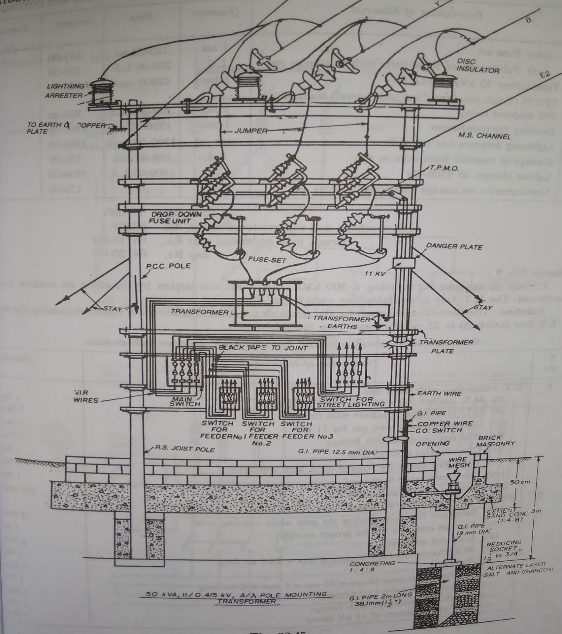

Material table-

Si no |  |  | Description | specification | Quantity
 | A | - For H .T arrangement
01 |  |  | Supports | RCC, 1m | 2 nos.
02 |  |  | Cross arms with its fitting accessories | M.S type , 100mm×50 mm×7.5  mm×2m | 2nos.
03 |  |  | Insulators with its fitting accessories | Disc insulator | 3 nos.
04 |  |  | Stay with its fitting accessories | For H.T. | 2 sets
05 |  |  | Lighting arrester with its fitting  accessories | For 11kv | 3 nos.
06 |  |  | Earthing With its fitting accessories | For 11kv, pipe earthing | 1 sets
B- For A.B switch arrangement
07 |  |  | Cross arms with its fitting accessories | 100mm×50mm×7.5 mm×2m | 2 nos.
08 |  |  | Angle iron cross arms to fixed the pin  insulators with its fitting accessories | M.S. type  100mm×50mm×7.5mm×0.75m | 3 nos.
09 |  |  | Insulators with its fitting accessories | For 11kv , pin type | 06 nos.
10 |  |  | AB switch organge operated air breaker switch with 6m long G.I pipe along with  its handle locking arrangement | For 11kv | 1 set
c |  | Drop – out arrangement
11 |  |  | Cross arm with its fitting accessories | M.S. type ,100mm×50mm×7.5 mm×  2 m. | 02 no
12 |  |  | Angle iron cross arm to support the  insulators with its fitting accessories | M.S. type , 100mm×50mm  ×7.5mm×0.75m | 03nos.
13 |  |  | Insulators with its fitting accessories | Pin type, 11kv | 6 no.
14 |  |  | Arcing or rod to be installed on the pin type insulator to supports the explosion  type fuse wire | For 11kv | 6 nos.
15 |  |  | Explosion type fuse wire | For 11kv | 1.5m
D- |  | Transformer installation
16 |  |  | Cross arms with its fitting accessories | M.S. , 100mm×50mm×7.5mm×2m | 02 nos.
17 |  |  | Angle iron cross arm to be used for base  plate | M.S. type ,  100mm×50mm×7.5mm×0.75m | 02 nos.
18 |  |  | M.S. channel cross arm to support the  T/F | M.S. type 100mm×50  mm×7.5mm×0.75m | 02 nos.
19 |  |  | Transformer | 63 kvA, 11/0.4kv | 01 no.
20 |  |  | Earthing with its bitting accessories | Pipe earting | 2 sets.
21 |  |  | L.T cable | 4 core aluminium type pvc insulation | 3m
22 |  |  | L.T. cable | ICTPN, 1100grade with rewirable 3-  unit | 01 no.
23 |  |  | Energy meter | 3-phase digital type | 01 no.
24 |  |  | Anti climbing wire | G.I type | 6m.
25 |  |  | Danger plate | 11kv | 02 nos

26 | Jumper conductor from HP arrangement  upto transformer installation | AcSR conductor | 25 m
27 | Binding wire at the rate 100 gm/pin  insulator | Aluminium type single core | 1.2 kg
28 | Sundries to complete the whole job | ------ | As per  required

Problem :-2

Prepare the list of materials required for plinth mounting substation of 11/0.4kv,50hz, 3-phase,250 kva T/F .

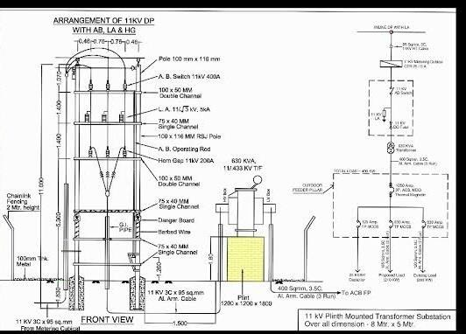

‘

Material table-

Si no |  |  | Description | specification | Quantity
A- H.T arrangement
01 |  |  | Supports at the substation | Rail pole, 12m | 2 nos
02 |  |  | Angle iron cross arm at the tapping  pole | 100mm× 50mm ×7.5mm ×1m | 1 nos
03 |  |  | Disc type insulator at the tapping  pole with its fitting accessories | Disc type for 11kv | 6 nos
04 |  |  | Angle iron cross arm with its fitting  accessories at the substation | M.S type ,100mm× 50mm  ×7.5mm×0.75m | 3 nos
05 |  |  | Lighting arrestor with fitting  accessories | For 11kv | 3 nos
06 |  |  | Earthing with its fitting accessories | For 11kv | 3 sets
07 |  |  | Stay with its fitting accessories | For H.T line | 3sets
08 |  |  | Over head conductor | ACSR 6/1×4.50 | 159 m
 | B | -AB switch arrangement
09 |  |  | Cross arm with its fitting accessories | M.S type 100mm× 50mm  ×7.5mm× 2m | 2 nos
10 |  |  | Angle iron cross arm to support the  pin insulator | M.S type 100mm× 50mm  ×7.5mm× 0.75m | 3 nos
11 |  |  | Insulators with its fitting accessories | Pin type 11 kv | 6 nos
12 |  |  | GOAB swith with 6m long G.I pipe  along with handle locking arrangmen | For 11 /0.4 kv substation | 1 set
 | C | - drop out arrangement
13 |  |  | Cross arm with its fitting accessories | M.S type 100mm× 50mm  ×7.5mm× 2m | 2 nos
14 |  |  | Angle iron cross are with its fitting  accessories | M.S type 100mm× 50mm  ×7.5mm× 0.75m | 3 nos
15 |  |  | Insulators with its fitting accessories | Pin type 11 kv | 6 nos
16 |  |  | Arcing rod to be fitting top of the  insulator | for11 kv | 6 nos
17 |  |  | Explosion type fuse wire | For 11 kv | 1m
D |  | - Transfomer installation
18 |  |  | Angle iron cross arm at the base plate of the T/F which its fixed in  the plinth | M.S type 100mm× 50mm  ×7.5mm× 0.75m | 2 nos
19 |  |  | Transformer | 250 kva, 11/0.4 kv | 1 no
20 |  |  | L.T cable | 4 core aluminium type pvc  insulated | 5 m
21 |  |  | Energy meter | Digital type 3-phase | 1 no
22 |  |  | L.T cable box | ICTPN with rewirable type  fuse unit | 1 no
23 |  |  | Earthing with its fitting accessories | Pipe earhing | 2 sets

24 | Jumper conductor | ACSR 6/11×4.50 mm | 30 m
25 | Danger plate | For 11 kv | 3 nos
26 | Anti climbing wire | G.I type | 6m
27 | Plinth | Cement concrete | 1:4:8
28 | Sundries to complete the whole job | -------- | As per  required

SHORT QUESTIONS

  - what is the maximum rating of the transformer which is installed in pole mounting substation?

Ans:- generally in pole mounting substation upto 250 KVA transformer in installed. (2)what is GOAB switch and where it is used?
Ans:- GOAB stands for gange operated air breaker switch and it is used to make and break the existing line manually.

---it is used in distribution substation and intermediate line of the H.T. distribution.

- what is TPMO switch where and why it is used?

Ans:- TPMO stands for triple pole manually operated switch and it is used in distribution substation as well as mid way of the H.T. line.

-it is used to make and break the existing line manually.

- what is TPIC switch?

Ans :- TPIC means triple pole iron clad main switch. Generally it is used in D. C. distribution. (5)what is TPICN switch and where it is used?
Ans :- TPICN stands for triple pole iron clad with neutral link. It is used in 3-phase distribution main switch.

(6)what is AB switch and why it is used ?

Ans:- AB stands for air breaker switch it is used in distribution substation as well as in the mid way of the H.T. lines

- It is used to make and break the existing. LONG QUESTION :-
various type of problems based on pole mount

- Draw the single line diagram of 33/11kv substation.
- Draw the single line daigram of 11/0.4kv substation

CH-5

OVER HEAD SERVICE CONNECTION (1-ɸ & 3-ɸ)

The over head line or cable or under ground cable connected between supplied line and consumer premises is called as service line or connection.

Generally service connection are of two types (1)single phase service connection
(2)3-phase service connection

Depending on the field situation the service connections are of two types (1)over head service connection
(2)under ground service connection Important points to be remember:-
-If the service pole is situated more than 45m. from the consumers premises then over head line may be used pole brackets.

-If consumers premises is more than 50m. from the service pole then one intermediate pole may be used

If the consumers load does not exceeds 1kw then 10SWG hard drawn copper conductors may be used.

If the consumers load does not exceeds to 2.5 kw then 8SWG copper conductor or 13.9 mm² aluminium conductor may be used .

Problem-1 -

Prepare a list of materials required for providing a service connection to a single staired building at 240 v 1-phase ,50hz a light & fan load of 5kw. The supply is to be given from an over head line 20 m away from the building

Solution-

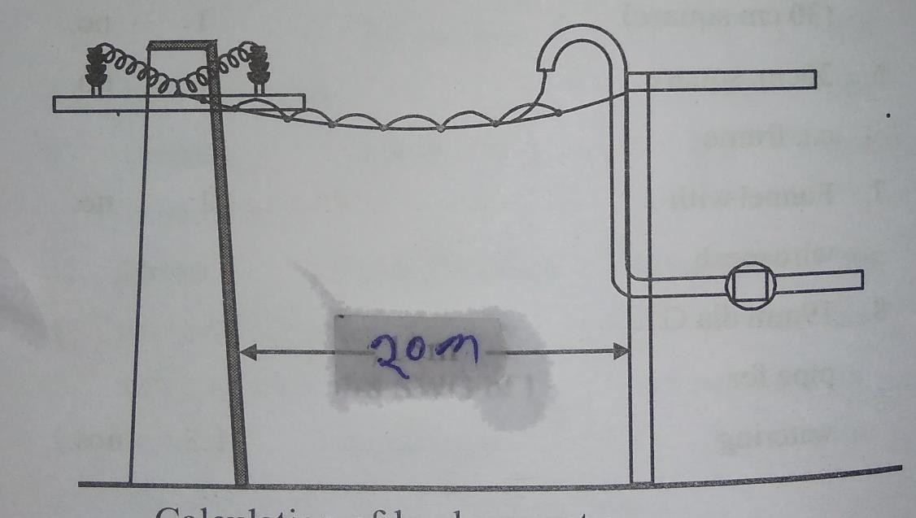

Calculation for short circuit current--- Given that
P=5kw=5000w V=240v
F=50hz

We know that

P=VI cosɸ

I=p/v cosɸ =5000/(240*1) =20.83=21A

So full load current =21A

So short circuit current= 1.5×full load current

=1.5×21

=31.5 A

Selection of cable ‘---

Through our sc current is 31.5 A but from the conductor table it is observe that for a current
rating of 34 A a pvc ‘insulated twin core aluminium conductor of 10mm² ,240 V ,whether proof is to be selected.

Calculation for length ‘of cable—

Net length = declared length +2% for sag +1m coil at the pole+1.5 m from coil to the over head conductor + 1m coil at the service pipe +3 m along the pipe +0.3 m for wall thickness +0.5 m for meter clearance

Net length=20+0.4+1+1.5+1+3+0.3+0.5

=27.7m

Considering 10% extra for twisting cutting,

‘gross length=27.7+2.7=30.4m

‘calculation for length of G.I wire—

Net length = declared length +2% for sag +1m at the pole +0.5 at the service pipe

=2.0+0.4+1+0.5=22m

Calculation for length of alluminium clip----

Let ‘us assume the length of G.I alluminium clip =10cm

Spacing of clip =20 cm

‘so length of the conductor =20m

=20×100

=2000 cm

So no of clip required =2000/20=100 nos

So lengh ‘of clip wire = 100× 10=1000 cm’=10m

Si no | Description | specification | Quantity
01 | Support wire | G.I type, 14SWG | 22m
02 | Cable | Pvc insulated twin core alluminium  conductor10mm²weather proof | 30.4 m

03 | Support wire clips | Alluminium type, 38 mm | 10 m
04 | Service pipe | G.I type ,50mm dia ,2m height | 01 no
05 | Clamps to supports the service pipe  along with it’s fitting accessories | G.I type with appropriate  diameter | 03 nos
06 | Energy meter | 240 v, 1-ɸ digital type | 01 no
07 | Board to fix the energy meter with it’s  fitting accessories | 45cm×60 cm ,iron clad with  bakelight cover | 01no
08 | Sundries to complete the whole job | ---- | As per  required

Problem-2-

Estimate the quantity of materials required to providing connection to a double storeyed
‘building with a loadof 4 kw at 240 v , 50 hz , separate meter are to be provided for the two floors . the distance between pole & building is 12 m & between the service bracket ‘& service board is 10 m

Solution-

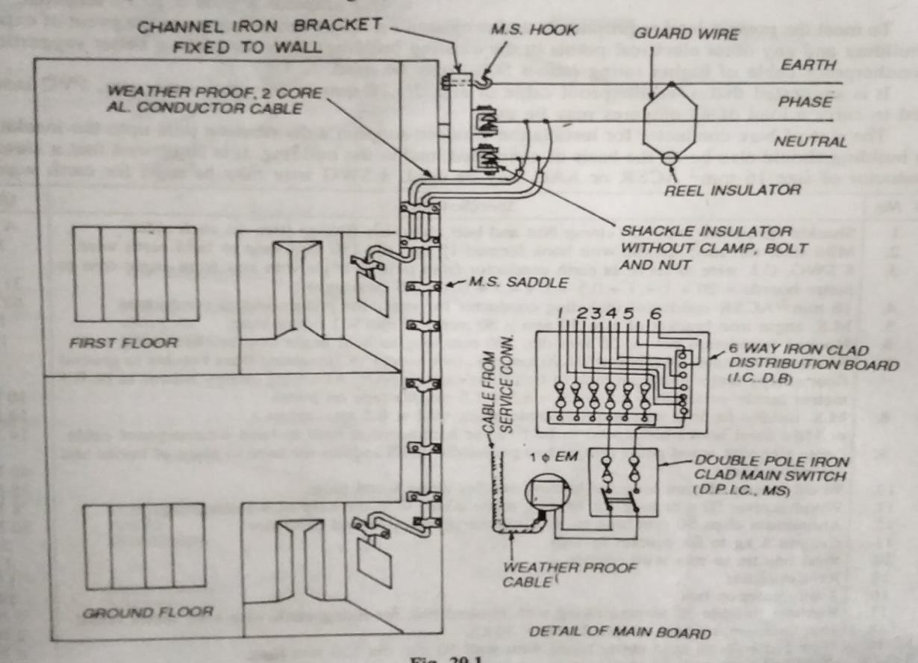

Calculation for short circuit current’- Given that ,
P=’4kw=4000w V=240v’
f=50 hz

we that

p= vi cosɸ

so i= p/v cosɸ

=4000/(240’*1)

=16.67 (full load)

Short circuit current =1.5 *full load current

=1.5*16.67

=25.05 A

Selection of cable—

Though our short circuit current is 25.05 A but from the conductor table, it is observed that for a current rating of 27 A pvc insulated twin core alluminium conductor of 6mm² 240 v weather ‘proof is to be selected.

Calculation for length of cable-

Net length =declared length +1m coil at the ‘pole +1.5 from coil to the over head conductor
+0.3 for wall thickness+ 0.5 m meter clearance

=12+1+1.5+0.3+0.5

=15.3 m

Calculation for length of over head conductor –

Net length ‘= 2(declared length +’exess of height from the pole top+2% for sag)

=2*(12+6.5+0.24)

=37.48m

Considering 10% extra for twisting & cutting So gross length= 37.48+3.748= 41.228 m Calculation for no of G.I clamps—
Assuming the installation G.I clamps at an interval of 1m along the angle iron &wall surface. Hence no of clamps required =11
Si no | Description | specification | Quantity
01 | Angle iron as the bracket with it’s  fitting accessories | M.S type , 50mm×50mm×  6mm× 10m long | 1no
02 | Cross arm with it’s fitting accessories | M.S type , 50mm×50mm×  6mm× 0.75m long | 01 no
03 | Insulators with its fitting accessories | Pin type,’ 440 | 02 nos.
04 | Over head conductor | AAC | 41.228 m
05 | Cable | pvc insulated twin core  aluminium conductor, 6mm² weather proof | 15.3m
06 | Clamps to hold the cable on the wall  with its fitting accessories | G.I. type | 11nos.
07 | Energy meter | 240v,1-ɸ, digital type | 02 nos.
08 | Board to fix the energy meter with its  fitting accessories | 45cm 60cm ,IC type with  backelite | 02 nos.
09 | Flexible conduit | Appropriate dimension | 01 m.
10 | Sundries to complete the whole job | --------- | As per  required

Problem-3

:- a firmer requireds to connect a three phase 37kw, 415 v, 50hz motor to a 3-ɸ 4 wire,’ 415 v/ 240v,50hz over head line. The distance of the service line from the firmer structure having 15m. the motor has an efficiency of 85% and power factor of 0.8 estimate the quantity of materials required for this purpose.

Solution:-

The neat sketch of service connection is dawn below.

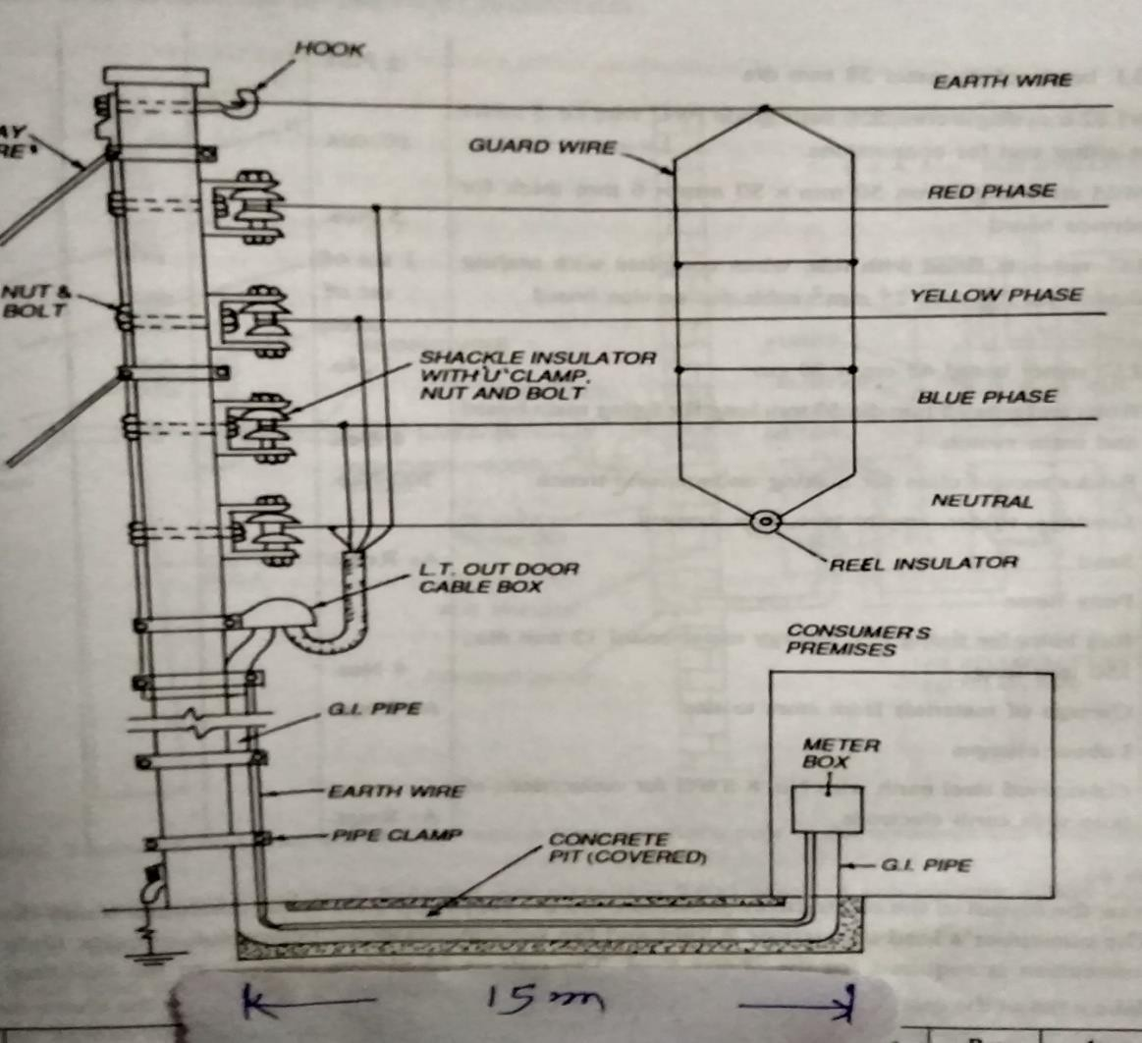

Calculation of short circuit current-

Output power of the motor (pout) =37kw =37000w We know that
Given efficiency’=85%=0.85

Efficiency= out put power/input power’

So , input ‘power’= out put power/efficiency

=37000/0.85

=43529.41 w

=43.5kw

But , input power= √3 vicosɸ

So , i=inputpower /√3 vcosɸ I=4352.42/(√3 *415*0.8)
=75.69A

So short circuit current =2* full load current

=2*75.69=151.38A

Selection cable:-

From the conductor table it is observe that far a current rating of 158A, 50mm² paper insulated , 1100v grade 4 core aluminium under ground cable is to be selected.

calculation for length of cable:-

net length= 2m from the over head conductor +5.5m along the core up to ground +0.2m trench depth +15m along the trench +0.2 trench depth +2m meter ciearance

= [2+5.5 +0.2 +15 +0.2 +2]

=24.9

=25m

Considering 10% extra for twisting & cutting Gross length = 25+2.5= 27.5 m
Calculation for no of G.I clamps’—

Assuming the distance between two clamps to be 1m, as per diagram we need 6 nos of clamps.

Material table-

Si no | Description | specification | Quantity
01 | Cable | 4 core alluminium type ,1100 v  grade ,50mm² paper insulated | 27.5 m
02 | ‘clamps to hold the cables with its  fitting accessories | G.I type appropriate dimension | 6 nos.
03 | L.T. cable box | TIPCN, with rewirable type fuse  unit | 01 no.

04 | Energy meter | 3-ɸ, digital type | 01 no.
05 | Board to fix the energy meter | 45cm×60cm iron clade with  backelite cover | 01 no.
06 | Earthing thimble | G.I. type | 02 nos.
07 | Sundries to complete the whole job | -------- | As per  required

Problem-4

:- A factory man requireds to connect a three phase 37kw, 415 v, 50hz motor to a 3-ɸ 4 wire,’ 415 v/ 240v,50hz over head line. The distance of the service line from the firmer structure having 60m. the motor has an efficiency of 85% and power factor of 0.8 estimate the quantity of materials required for this purpose.

Solution:-

The neat sketch of service connection is dawn below.

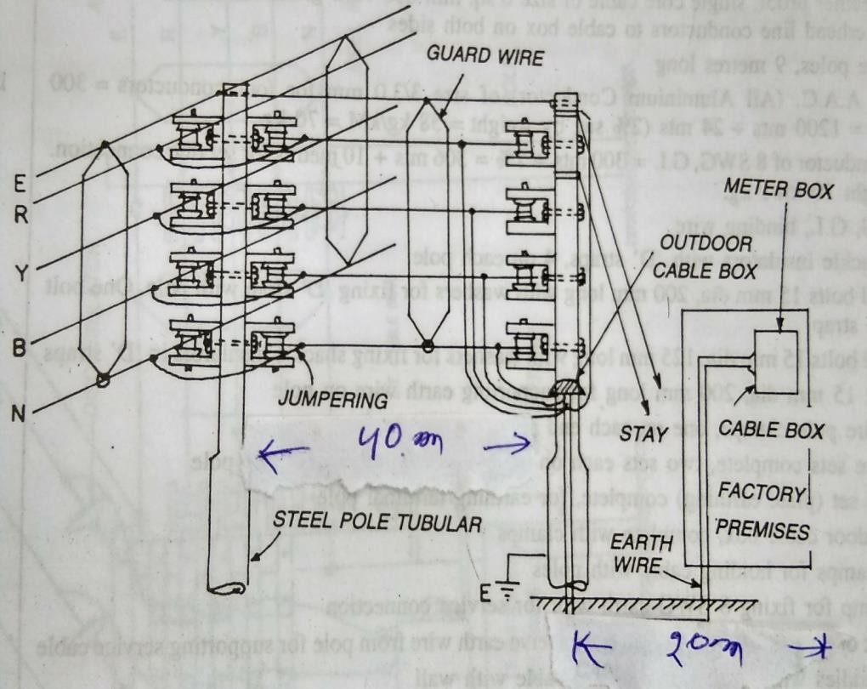

According to I.E rule ,’if cosumer premises is more than 50 m from the service pole then one intermediate pole is used.

So according to question

Service pole to intermediate pole distance is 40 m which used in bare conductor according to over head line process.

Intermediate pole to meter box distance is 15 m which used in under ground insulated wire according to service line process.

Calculation for over head line accessories-

No ‘of pole =1

Cross arm- 1+1=2

No ‘of shackle insulator -4+4=8 Calculation for length of over head conductor—
Net length of conductor=4 (total length ‘of line +2% of sag)

=4(40+0.2)

=4*(40.2)

=80.8=81m

Calculation for service line accessories- Calculation of short circuit current-
Output power of the motor (pout) =37kw =37000w We know that
Given efficiency’=85%=0.85

Efficiency= out put power/input power’

So , input ‘power’= out put power/efficiency

=37000/0.85

=43529.41 w

=43.5kw

But , input power= √3 vicosɸ

So , i=inputpower /√3 vcosɸ I=4352.42/(√3 *415*0.8)
=75.69A

So short circuit current =2* full load current

=2*75.69=151.38A

Selection cable:-

From the conductor table it is observe that far a current rating of 158A, 50mm² paper insulated , 1100v grade 4 core aluminium under ground cable is to be selected.

calculation for length of cable:-

net length= 2m from the over head conductor +5.5m along the core up to ground +0.2m trench depth +20m along the trench +0.2 trench depth +2m meter ciearance

= [2+5.5 +0.2 +20 +0.2 +2]

=29.9

=30m

Considering 10% extra for twisting & cutting Gross length = 30+3= 33 m
Calculation for no of G.I clamps’—

Assuming the distance between two clamps to be 1m, as per diagram we need 6 nos of clamps.

Material table-

Si no | Description | Specification | Quantity
over head line materials
01 | Supports | RCC, 9m | 01 no
02 | Cross arm with its fitting accessories | Angle iron cross arm | 2 nos
03 | Insulator with its fitting accessories | Shackle insulator | 8 nos
04 | Over head conductor | ACSR, 6.1×3.00mm long | 81m
05 | Earthing with its fitting accessories | For 440 v lines | 1 set
06 | Stay set with its fitting accessories | For 440 v | 1set

07 | Binding wire at the rate 100gm per pin  insulator | Alluminium single core | As per  required
08 | Anticlimbing wire at the rate 3m per  pole | G.I type | ‘3 m
09 | Danger plate | 440v | 1 no
Under ground Service line materials
10 | Cable | 4 core alluminium type ,1100 v  grade ,50mm² paper insulated | 33 m
11 | ‘clamps to hold the cables with its  fitting accessories | G.I type appropriate dimension | 6 nos.
12 | L.T. cable box | TIPCN, with rewirable type fuse  unit | 01 no.
13 | Energy meter | 3-ɸ, digital type | 01 no.
14 | Board to fix the energy meter | 45cm×60cm iron clade with  backelite cover | 01 no.
15 | Earthing thimble | G.I. type | 02 nos.
16 | Sundries to complete the whole job | -------- | As per  required

Short question :-

- why the core of service cable is mostly selected as aluminium?

Ans- the core of the service cable is selected as aluminium because the over head conductor at the service is also aluminium. Hence to avoid interrupition of energy supply due to dis-similarity of material contact.

- write the size of G.I. wire used as a support wire in service line. Ans- generally 14 SWG G.I. wire used as a support wire in service line.
- at what condition over head bare conductor is used for providing service connection.

Ans- the over head bare conductor is used for providing the service connection only when the distance between the distribution pole and consumer premises exceeds 45m.

- why G.I. is used for carrying cable for service connection is bent back at the upper end with opening facing downward.

Ans- the G.I. pipe is used for carrying cable for service connection has been made bent to prevent entering of rain water into the pipe.

- what are the various types of service connection.’

Ans- depending on the field situation service connections are of two types. (1)overhead service connection
(2)underground service connection depending on the voltage it is two types (i)single phase service connection
- 3-ɸ service connection

Long question-

Q-1) Prepare a list of materials required for providing a service connection to a single staired building at 240 v 1-phase load of 2kw. The supply is to be given from an over head line 20 m away from the building.draw the sketch

- Prepare a list of materials required for providing a service connection to a single staired building at 240 v 1-phase ,50hz a light & fan load of 5kw. The supply is to be given from an over head line 20 m away from the building

- Estimate the quantity of materials required to providing connection to a double storeyed ‘building with a loadof 4 kw at 240 v , 50 hz , separate meter are to be provided for the two floors . the distance between pole & building is 12 m & between the service bracket ‘& service board is 10 m

Chapter-2 ELECTRICAL INSTALLATION

Wiring system:- it is defined as a network of wires connecting with various electrical load from supplier meter boards through the safety and controlling device.
Various systems adopted for distributing electrical energy :-

In our country basically following two types of systems are adopted for distributing electrical energy.

(i)distribution board system (ii)tree system
- distribution board system :-
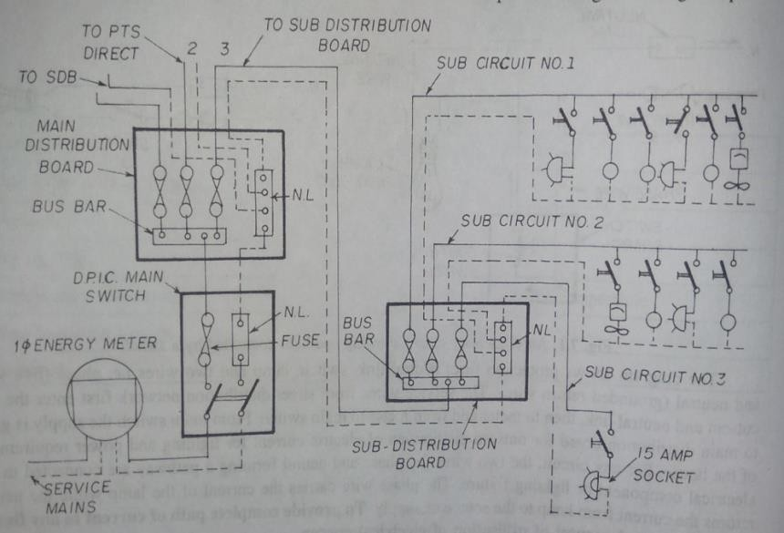

This is one of the widely used energy distribution system in our country, this system has an iron clad, in each circuit one cutout must have to be installed on the iron clad or board so this board sometimes called as fuse board or distribution board.
  - For every circuit phase ad neutral wire must be taken from the respective bus bar which is also fitted on the distribution board.
  - In this system each circuit must contain 10 points or 800 watt.

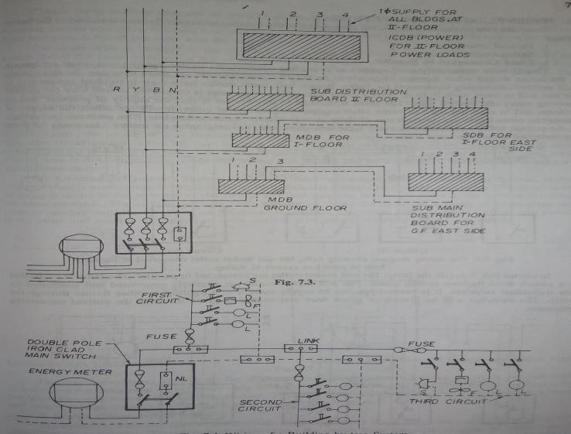
  - TREE SYSTEM :-

This system of wiring is not used frequently due to the following reasons

(i)the extream end load or last end load can not get the declared voltage due to resistive drop. (ii)fuses are scertered which causes more expensive.
- in this system fuses are connected in the phase wire, neutral link connectors are also connected in neutral and phase wire respectively for each circuit phase and neutral are taken from the connector and neutral links as shown in above figure.

Methods of wiring :-
Generally we have two types of methods for wiring that are

  - joint box

  - loop in system Joint box system :-
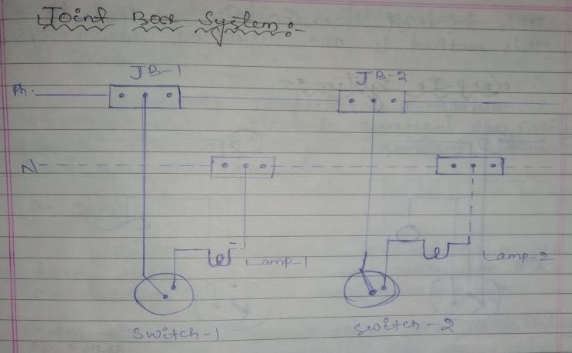

In this system phase and neutral wires are connected with the joint boxes a shown in above figure for each electrical load phase wire is to be taken from the joint box through the switch and neutral wire from the joint box directly to the load by this way for each no of electrical loads, joint boxes are used and accordingly switches are used.

This method is a costlier method. Hence this method is not adopted now a days. Loop – in system :-
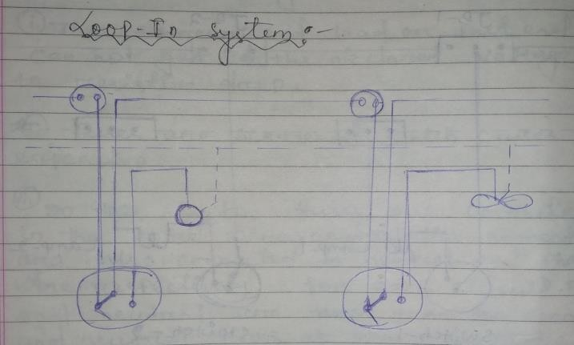

In this system phase wire is to be controlled by the switches and the same phase to be connected to a particular load as shown in the above figure, the neutral is directly connected to the each load but not through the switches. This system of wiring is widely use now a days.

Types of wiring :- in the wiring system may be domestic or industrial following wiring systems are adopted

- Cleat wiring
- Wooden casing & capping wiring
- CTS or TRS or LEAD seathed wiring
- Conduit wiring (i)Cleat wiring :-
At first in this wiring demarkation is given on the wall surface, using hand drill holes are made long the demarcation at 3cm to 60cm apart then wooden gutties (plugs) of size 38mm×38mm of 6.5c.m. long are placed in the drilled holes. Then the base cleats are to be fixed on the gutties then VTR cables are takn through the base cleats and immediately after it the top cleats are screwed over the base cleat. Now the cables are permanently placed in the cleats.

Application :-

- This wiring system is basically used in un damped places and also where a temporary wiring is needed.

Wooden casing & capping wiring :-

In this wiring demarcation is given on the wall surface at a height of 3m from other ground.
Using drilling holes are made along the demarcation line with 15cm apart. The wooden gutties (plugs) are inserted in the drilled holes the wooden casing are fixed on the gutties by means of screw. The length of such casing is about 2.5m to 3m. After it PVC or VIR cables are drawn through the casing then the top cover named as capping is now fixe by the help of screws.

- .

Application :-

This wiring system is basically used in low voltage (1-phase , 240v) domestic wirings. Normally in dry places where there is no risk of fire.

CTS or TRC or lead seathed or batter wiring :-

In this wiring demarcation is given on the wall surface and height 3m from ground using hand drill holes are created along the demarcation line of distance 75cm apart. The wooden guties are plugged of the size 32mm× 8mm about 6.5 cm. Long are inserted in the drilled holes then for holding the cables links is made with tinned brash are fixed on the batten with an interval of 10cm. In case of horizontal and 15cm. In case of vertical then the teak wood batten of different sizes as applicable such as 13 ×13mm, 19 ×13m, 25× 13mm and 31 ×13mm etc. Are fixed over the gutties by means of machines screws or wooden plugs with appropriate size. Then TRs or CTS cables are laid over the nail pins are twisted so as to hold the cable permanantely.

- For providing the no. Of cables and link pins the different size of batten are mentioned in the following table.
Batten size | Number and size of link clips | Number of single core cable  to carried out
13mm ×13mm | 1 ×38mm | 2
19mm ×13mm | 1 ×50mm | 3
25mm ×13mm | 2 ×28mm | 4
31mm ×13mm | 1× 38mm  & 1 ×50 mm | 5

APPLICATION-

This type of wiring is used for lo voltage installation in domestic, commercial or industrial workshop.

CONDUIT WIRING-

In this wiring the demeritation is given on the wall surface at a height of 3 m from the ground using hand drill holes are created along the demeritation line at a distance of 75 cm apart the wooden gutties or plug of size 32 mm× 8mm about 6.5 long are inserted in the drilling holes. Then the base shaddle is fixed on the gutties .

-in this wiring,all wires are enclosed in steel pipe known as conduit. It is lie metal is annealed to permit to easy bending. The inner surface of the conduit is carefully prepared so that the wires can be easily pulled into it with a minimum of effort .

There are three types of conduit wirings

- Concealed wiring
- Surface conduit wiring
- Flexible conduit wiring

LEAD OR METAL SHEATHED WIRING :-

The conductors having insulated covering of V.I.R are covered with an outer sheath of lead or lead alloy. The max^{m} thickness of lead covering thus formed may not exceed 1 mm or 1.5 mm .this metal sheath provides toughness and gives protection to the cable against mechanical injury and atmospheric corrosion.
WIRING MATERIALS & ACCESSORIES:-

(1) Conductor:-
Generally conductor is a medium through which electric current can easily flows. following are the important materials use for the conductors.
- Copper :-
- Copper materials is used as a best material for the conductor. Its conductivity is comparatively high.
- At 20 ⁰c temperature the resistivity of copper is 1.786×10⁻⁸ Ωm.
- The specific weight of copper is 8900kg/m³.
- It has high resistance to corrosion , oxidation and pitting .
- aluminium :-
- in the electrical field basically in transmission, distribution and utilization it dominates the copper material.
- It is the next immediate choice of material for the conductor.

- Its resistivity is 2.87× 10 ⁻⁸Ωm at 20⁰c. .
- This material is less cost ad used in different cables as well as overhead bare conductors.
- It is also affected by oxidation. (2)wires & cables :-
The term wire is very much familiar in wiring system which meaning is a strip of bare conductor with negligible thickness.

- Similarly the term cable is also a popular word used in wiring system. Its meaning is a wire covered with insulated materials.
- A cable may be single core, double core & more core. (3)Insulating materials:-
The soul purpose of insulating materials used in cable or covered with the bare conductor is to prevent leakage current . from the conductor o core.

Following are the important properties of a insulating materials.

- High resistivity
- High dielectric strength
- High resistant to moisture, acids & alkalies.
- Capable of withstanding high rupturing voltage.
- Capable of withstanding at high temperature.
- High flexibility.

  - TYPES OF INSULATINGS MATERIALS—

Followings are the important insulating materials that are used in various electrical field.

- Rubber
- Vulcanized Indian rubber (VIR)
- Impregnated paper
- Poly vinyle chloride (PVC)
- Silk & cotton

  - MECHANICAL PROTECTION-

Generally a cable should be design in such a manner that it can help mechanical stability .usually in power cables to protect against mechanical injury two layers of steel tap are used or now a days aluminium sheathing is introduced .

(6) TYPES OF CABLES USED IN INTERNAL WIRING :-

Generally cables are categorized based on the conductors used , no of ores, amount of voltage supply an type of insulations. Hence following are the important cables used in internal wiring

(i) VIR (240v /415v and 650v /1100v)
- TRS or CTS (240v /440v and 650v /1100v) TRS-tough rubber seathed
CTS-cap tyre seathed
- Lead seathed cable (240v/415v)
- PVC (poly vinyle chloride)(240v /415v and 650v /1100v)
- Weather proof cable(240v /415v and 650v /1100v )
- XLPE cable – it means cross link polythiline insulated aluminium conductor armoured cable. (7)MULTI- STRANDED CABLES :-
The multi – strand cable is composed of several fine copper wires.

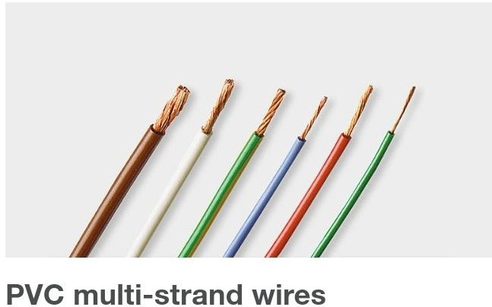

- VOLTAGE GRINDING OF CABELS :-

It is the process of archiving uniform distribution of dielectric stress or voltage gradient in a dielectric of cable.

  - There different types voltage grade (240v/415v), (650/1100)v,(240/415)v mans :-
  - Voltage between conductor & earth is 240v.
  - Voltage between two conductors is 415 v.

- GENERAL SPECIFICATION OF CABLE :-

While purchanging or estimating the cable we must emphasise on following factors.

- Size of the cable (19/ 2.24 mm , 7/1.70 mm etc.)
- Types of conductors used (Aluminium or copper)
- No of core (single core, double core, 3 core etc)

- Voltage grade (240/ 415v or 650 /1100v etc.)
- Types of insulation material (PVC OR TRS etc)

- MAIN SWITCH & DISTRIBUTION BOARD :-

According to the IE rule a suitable linked switch has to be provided immediately after the meter
board .

Following are the important specifications of main switches according to their applications.

- 240v , 16A , DPIC switch for two wire DC. Circuit or 1- phase.
- 500v, 32A /63A/100A /150A TPIC main switch for 3 wire D.C. circuit.
- 415v, 32A /63a/ 100A /150 A TPICN used for 3- phase 4 wire A.C. circuit.

Similarly for distribution board we have main specifications as two ways, three ways , 4 ways etc.

- CONDUIT :-

Generally in household wiring we use following type of circuit

- Light gauge steel conduit
- Heavey gauge steel conduit
- Flexible conduit
- PVC conduit

- CONDUIT ACCESSORIES & FITTINGS:-

In the wiring system basically for conduit wiring following accessories are frequently used.

- Bend (L- conduit) conduits and T- conduits.
- Bushings or coupler (male or female conduits )
- Clip and sadels conduits.
- Conduit boxes (2 ways, 3ways, 4 ways etc.)

- LIGHTING ACCESSORIES &FITTINGS :-

For lighting purpose we use following accessories and fittings.

  - Switches
Following switches are generally used in household wiring
- One way switch
- Two way and two way centre of switch
- DP main switch
- Push button switch
- Bed switch

- Table lamp switch
- Tumbler or surface switches
- Flush switches
  - Ceiling rose :-
Ceiling rose may be of two plates ceiling rose is basically used for ceiling fans.
  - Socket outlets :-
Depending on the field application a socket outlet may be of two pin , three pin, five pin and six pin of 240v ,6A/ 16A or 32A etc.
  - Lamp holders :-
We have following types of lamp holders
    - Batter holder
    - Pendant holder
    - Angle holder
    - Slanting holder
    - Bracket holder
    - Water type bracket holder
    - Miniature lamp holder

From the above holders the specification may be 5A , 250A ,backelite holder of any make.

FUSE :-

It is a low melting point electrical safty device that operates to provide over current protecting .

FUSE ELEMENT :- it is made of zinc, copper , silver, aluminium or alloy .

Best fuse is alloy of lead & ti which has low melting point & very high resistance. TYPES OF FUSE:-
- Drop – out fuse
- Striker fuse
- Switch fuse
- Cartidge type (HRC fuse)
- Explosion type HV fuse Determine the current rating of a fuse :-
The value of current at which the installation is working without any damage is the current rating of the fuse. Following are the main factors which determine the current rating of a fuse :

- Minimum size of cable or fuse for mechanical reasons.
- Voltage drop.
- Current carrying capacity.

- Type of insulation of the fuse.
- The unit of fuse is – ampere .

Current rating of fuse element :-it is the value of maximum current which the fuse element can normally carry without overheating or melting at normal full load current.

FUSING CURRENT :- it is the maximum value of current at which, the fuse element melts and thus disconnects the circuit.

FUSING FACTOR :- it is defined as the ratio of minimum fusing current to the fusing rating of the fuse element i.e.

Fusing current =minimum fusing current/current rating of fuse element .

CUT – OFF CURRENT :-the maximum value of fault current actually reached before the fuse melts is called cut – off current.

Different types of protective devices used both in domestic & factors

- Fuse
- MCB (miniature circuit breaker) LIGHTING SCHEME:-
Principle of good lighting :-

- It is the requirement of general lighting is to obtain uniform, diffused and glareless lighting. This can be obtained by using fluroscent lighting or by using lamps made of diffusing glass
- Light intensity is chosen is depends upon choosing of area.

Types of lighting schemes

- Direct lighting
- Semi – direct lighting
- Semi – indirect lighting
- Indirect – lighting Direct lighting :-
This light is directly made to fall on the working plane, if proper reflectors are used, about 80% to 90% of total light flux can be made to fall on the working plane

- It used industrial & outdoor lighting.

Semi – direct lighting :-

In this system semi direct reflectors are use as a result, 60 to 90% of the total light flux is made to fall on working plane.

Semi – indirect lighting :-

It produces very soft lighting system the 60% to 90% is thrown upward to the ceiling for reflect & the remaining light reaches the working plane directly.

- This type scheme is adopted for indoor light decoration purposes.

Indirect lighting :-

In this system 90% to 100% of total light flux is thrown upward to the ceiling for diffused reflection by using inverted or bowl reflectors in this system glare is reduced is softer.

- This scheme is used in decoration purpose.

General rules of wiring :-

- In factor lighting :- the direct lighting scheme is used.
- Public lighting installation :- both direct & semi direct lighting scheme is used.
- Street lighting :- the wiring light points are installed approximates nearer to provide uniform illumination.

DETERMINATION OF NO OF POINTS TO BE USED IN A CIRCUIT & TOTAL LOAD (NO OF SUB – CKT)

Luminous flux (φ) :- it is the total lumen produced by lamp.

- Unit of flux is :- lumen Total lumen given by lamp :-
φ = N × wattage of each lamp × luminous efficiency of each lamp.

= total lumen falling on working plane

φ _{net} =φ ×cu × Mf

cu – co- efficient of utilisation Mf – maintance factor
Φ – total lumen by lamps

Φ _{net} = total lumen fall on working plane

Illumination (E) :- it is the total lumen in working plane per unit area.

E = φ _{net} ÷ A (A = light falling area)

φ _{net} = E × A

= φ ×CU× MF =E× A

= N× watt / lamp× luminous efficiency× CU× MF = E ×A N = E ×A ÷( watt / lamp × luminous efficiency × CU× MF)

- Earthing system :-

We know that earthing is defined as a connection of the neutral point of the supply system and non- current carrying parts of electrical apparatus such as metallic frame work, metallic covering of cables, earth terminal of the socket outlet and stay wires etc. To the general mass of the earth so as to discharge the electrical energy immediately to the earth without any danger.

  - Resistance of earth:-
According to IE rules the resistance should be low enough to cause the flow of electric quickly. The earth resistance is not equal in all places because it depends on the moisture contains and the type of soils etc.
- Therefore following are the important values of earth resistance that can be permitted.
- For large power station – 0.5Ω
- Major power station - 1Ω
- Small substation - 2Ω
- In all other cases - 5Ω

The resistance from the earth plate to any point in the installation is 1Ω

  - Size of earth continuity conductor :-
Normally we use 14 SWG or 16 SWG o 18 SWG G.I. or copper.
  - Distance of earth from the building :-
In general the distance of earth electrode from the building should not b less than 1.5 m
  - Methods of earthing :-
Following methods are adopted for earthing :- (i)Strip or wire earthing :-
For copper dimension is 25mm ×1.6mm For G.I. dimension is 25mm ×4mm

- rod or spike earthing :-

Various rods are available in market for earthing that are 12.5 mm dia solid rods of copper and 2.5 m long .

  - 16 mm dia solid rods of G.I. or G.S. of 2.5 m long and 25mm dia G.I. of 2.5 m long.

- pipe earthing :-

Pip earthing the various type of pipes are available in different sizes that are 40mm with 2.5 m long G.I. and 19mm dia with 1.25 m long G.I.

Q-2- prepare the list of materials required for pipe earthing and also draw the neat sketch

Material table

Si no | Description | specification | Quanity
01 | G.I pipe | 38mm dia,2.5 m long | 01 no
02 | G.I pipe for watering | 19mm dia,1.5m long | 01 no
03 | G.I pipe | 13mm dia ,4.5m long | 01 no
04 | G.I wire | 6SWG | 12m
05 | G.I lugs | G.I type | 02 nos
06 | G.I nut bolt | 10 mm dia ,16mm dia | 04 nos
07 | G.I bends | 13mm dia | 02 nos
08 | Cast iron frame | 30cm *30 cm | 01 no
09 | Cast iron cover | 30 cm * 30 cm | 01 no
10 | Funnel | - | 01 no
11 | Channel | - | 10kg
12 | ¤ Common salt | - | 10kg
13 | Sundries to complete the whole job | - | As per required

- plate earthing :-

In plate earthing different sizes of plates are available in market that are For copper plate size 60cm × 60cm ×3mm
For G.I. plte size 60cm× 60cm × 6mm
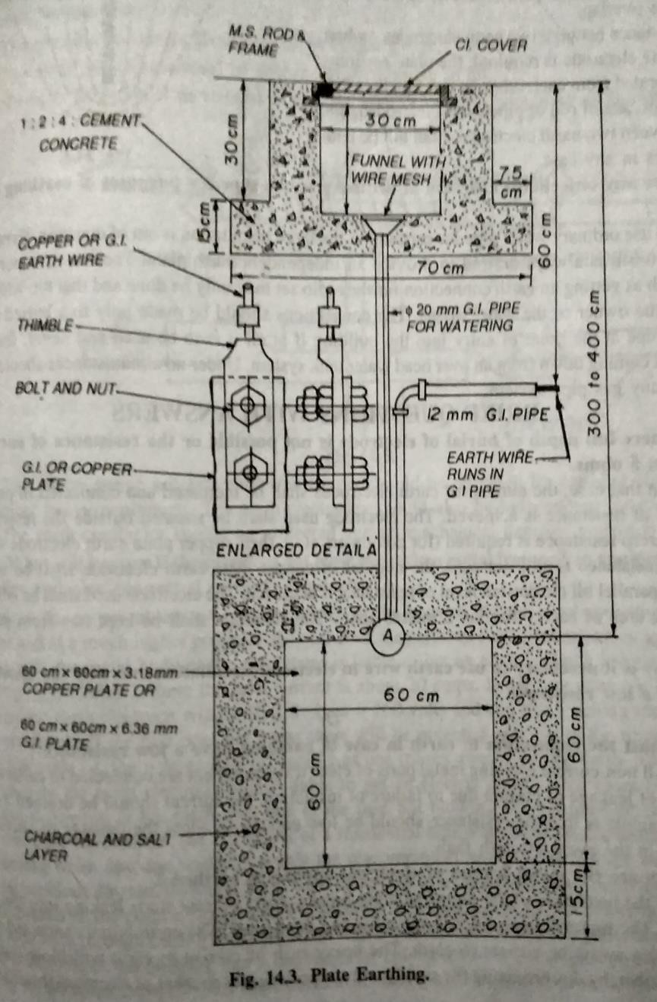
Material table :-

Si no. | Description | Specification | Quantity

01 | G.I plate or cu plate | 60 cm ×60cm× 6.36mm 60 cm× 60cm ×3.18 mm | 01 no  01 no
02 | G.I. pipe for watering | 20mm dia , 2m long | 01 no
03 | G.I pipe | 12mm dia ,2.3 m long | 01 no
04 | GI wire | 6 SWG | 12 m
05 | GI lugs | GI types | 02 nos
06 | G.I nut bolt | 10mm dia ,16mm dia | 04 nos
07 | Cast iron frame | 30cm×30cm | 01 no
08 | Cast iron cover | 30cm×30cm | 01 no
09 | Funnel | -------- | 01 no
10 | Charcoal | --------- | 10kg
11 | Salt | -------- | 10kg
12 | Sundries to complete hole job | ------ | As per required

Short questions :-

- According to rural electrification an I.E. rules each circuit contains haw many points and power ratings.
Ans :- according to rural electrification and I.E rules each circuit contains 10points and 800watt.
- What is height of ceiling, switch board, horizontal run up and ceiling fan from the ground? Ans :-according to I.E rules the height of ceiling must be 3.5m from the ground and height of switch board is 1.5m and the height of horizontal run up is 3m and the height of ceiling fan is 2.75m.
- In a 1- phase A.C. supply fuse is connected to which wire.
Ans :- in a 1- phase A.C. supply fuse is connected to fuse wire.
- Write the specification of main switch which is used for lighting purpose only.
Ans :- the standard specification of a main switch for lighting is DPIC, 6A 240v
- What is the general rule to install a switch board in a room near the entrance door? Ans :-generally in left side of the entrance door of a room switch board is installed.

- Write the full form of SPST switch and DPDT switch.
Ans :- the full form of SPST switch is single pore single through.
The full form of DPDT switch is double pole double through.
- What is the permissible voltage drop of internal house wiring?
Ans :-the permissible voltage drop of internal house wiring is ±2 %.
- What is the full form of PILC ?
Ans :- the full form of PILC is PVC insulated live conductor.
- What is the full form of AAC , ACSR, TRS, VIR and PVC? Ans :- the full form of
AAC- all Aluminium conductor
ACSR – Aluminium conductor steel reinforced. VIR – Tough Rubber Seathed.
PVC – poly vinyle chloride.
- Why fuse is not provided in neutral of A.C. supply?
Ans :- since neutral wire is the return path of A.C. supply in case of unbalanced load or any fault condition the heavey current returns to that neutral path of fuse it place then the current can not pass to that path. And the system will be damage.
- State the criteria required to fulfil for selecting a conductor for an installation.
Ans :- the criteria required to full fill for selecting a conductor for an installation are
- Types of conductor
- No. Of core
- Current carrying capacity
- Voltage grade
- Types of insulation
- State the difference between main distribution board and sub-distribution board.
Ans :-main distribution board
  - The main distribution board provide power feeds to other distribution board or sub-distribution board but the sub distribution board will provide power feed to the individual load.
- What is the difference between fuse & MCB. Ans:- fuse:-
  - It is made up of piece of metal that melts when over heated or large amount of current flows.
  - It is melts then it replace by now one. MCB :-
  - The miniature circuit breaker have an internal switch mechanism that can be tripped by an abnormal cases or when excess of current flows.
- What is TPIC and TPICN main switch and where it is used?
Ans :-the full form of TPIC is triple pole iron clad.
  - It i used in three wire D.C. distribution line.
  - The full form of TPICN is triple pole iron clad with neutral link. And it is used in 3- phase A.C. supply.
- Write the full form of DPIC main switch and where it is used.

  - The full form of DPIC is double pole iron clad and it is used in1-phase A.C. and two wire D.C. distribution line.
  - LONG QUESTION :-
  - Prepare the list of materials required for plate earthing and also draw the neat sketch.
  - Prepare the list of materials required for pipe earthing and also draw the neat sketch.

Chapter-3 INTERNAL WIRING

Types of wiring :- in the wiring system may be domestic or industrial following wiring systems are adopted

- Cleat wiring
- Wooden casing & capping wiring
- CTS or TRS or LEAD seathed wiring
- Conduit wiring (i)Cleat wiring :-
At first in this wiring demarkation is given on the wall surface, using hand drill holes are made long the demarcation at 3cm to 60cm apart then wooden gutties (plugs) of size 38mm×38mm of 6.5c.m. long are placed in the drilled holes. Then the base cleats are to be fixed on the gutties then VTR cables are takn through the base cleats and immediately after it the top cleats are screwed over the base cleat. Now the cables are permanently placed in the cleats.

Adavantages-

  - It is easiest method of installation
  - Fault finding is easy & repairing is also required very less time
  - Dismentaling is easy & quick Disadvantages-
- It is temporary wiring system.
- It is not good looking
- Since the cables are exposed to the air ,so it may chemically affected which causes damage to the insulations.

Application :-

  - This wiring system is basically used in un damped places and also where a temporary wiring is needed.

Wooden casing & capping wiring :-

In this wiring demarcation is given on the wall surface at a height of 3m from other ground.
Using drilling holes are made along the demarcation line with 15cm apart. The wooden gutties (plugs) are inserted in the drilled holes the wooden casing are fixed on the gutties by means of screw. The length of such casing is about 2.5m to 3m. After it PVC or VIR cables are drawn through the casing then the top cover named as capping is now fixe by the help of screws.

Advantages :-

  - To same extend it is easy to installed.
  - Fault finding and repairing is also easy.

Disadvantages :-

  - There is a risk of fire hazard.
  - It is costlier now a days.
  - It can not be used in damped places.

Application :-

This wiring system is basically used in low voltage (1-phase , 240v) domestic wirings. Normally in dry places where there is no risk of fire.

CTS or TRC or lead seathed or batter wiring :-

In this wiring demarcation is given on the wall surface and height 3m from ground using hand drill holes are created along the demarcation line of distance 75cm apart. The wooden guties are plugged of the size 32mm× 8mm about 6.5 cm. Long are inserted in the drilled holes then for holding the cables links is made with tinned brash are fixed on the batten with an interval of 10cm. In case of horizontal and 15cm. In case of vertical then the teak wood batten of different sizes as applicable such as 13 ×13mm, 19 ×13m, 25× 13mm and 31 ×13mm etc. Are fixed over the gutties by means of machines screws or wooden plugs with appropriate size. Then TRs or CTS cables are laid over the nail pins are twisted so as to hold the cable permanantely.

  - For providing the no. Of cables and link pins the different size of batten are mentioned in the following table.
Batten size | Number and size of link clips | Number of single core cable  to carried out
13mm ×13mm | 1 ×38mm | 2

19mm ×13mm | 1 ×50mm | 3
25mm ×13mm | 2 ×28mm | 4
31mm ×13mm | 1× 38mm  & 1 ×50 mm | 5

Advantages :-
  - It is has highly durable.
  - It can withstand the action of acids and alkalies.
  - It’s installation is easy
  - Fault finding can be detected easily DISADVANTAGE-
  - It is very costlier now a days
  - There is a risk of fire
  - It can not be used in damped place
  - Skilled labour is required for making the smooth batten APPLICATION-
This type of wiring is used for lo voltage installation in domestic, commercial or industrial workshop.

CONDUIT WIRING-

In this wiring the demeritation is given on the wall surface at a height of 3 m from the ground using hand drill holes are created along the demeritation line at a distance of 75 cm apart the wooden gutties or plug of size 32 mm× 8mm about 6.5 long are inserted in the drilling holes. Then the base shaddle is fixed on the gutties .

-in this wiring,all wires are enclosed in steel pipe known as conduit. It is lie metal is annealed to permit to easy bending. The inner surface of the conduit is carefully prepared so that the wires can be easily pulled into it with a minimum of effort .

There are three types of conduit wirings

- Concealed wiring
- Surface conduit wiring
- Flexible conduit wiring

LEAD OR METAL SHEATHED WIRING :-

The conductors having insulated covering of V.I.R are covered with an outer sheath of lead or lead alloy. The max^{m} thickness of lead covering thus formed may not exceed 1 mm or 1.5 mm .this metal sheath provides toughness and gives protection to the cable against mechanical injury and atmospheric corrosion.

Advantages :-

  - It can be used in places exposed to sun or main, provided no joint is exposed
  - It may have comparatively a longer site Disadvantages :-
  - It is costly as compared to TRS wiring system
  - If proper earthing is not done an insulation is damaged, the metal sheath becomes alive & gives electric shock
  - Skilled labour is required to execute the work
  - It may not be suitable for places where chemical corrosion may occur .

INDUSTRIAL WIRING-

In this wirings the different rating of motors are used , so the power equipments are used in this wiring such as main switch board , starter etc

Determination of input power of motor—

Input in watt = (rated BHP of motor ×735.5)/motor efficiency Determination of input current of motor-
Input current= (rated BHP of motor ×735.5)/(p.f × voltage × efficiency) (1-φ)

Input line current= (rated BHP of motor ×735.5)/( √3 ×p.f × voltage × efficiency) (3-φ)
Selection & rating of cable---

The selection & rating of cable depends upon current drawn by motor at full load . but starting current greater than full load current. So finally selection of cable is chosen by starting or over load current .choosing of cable from below table.

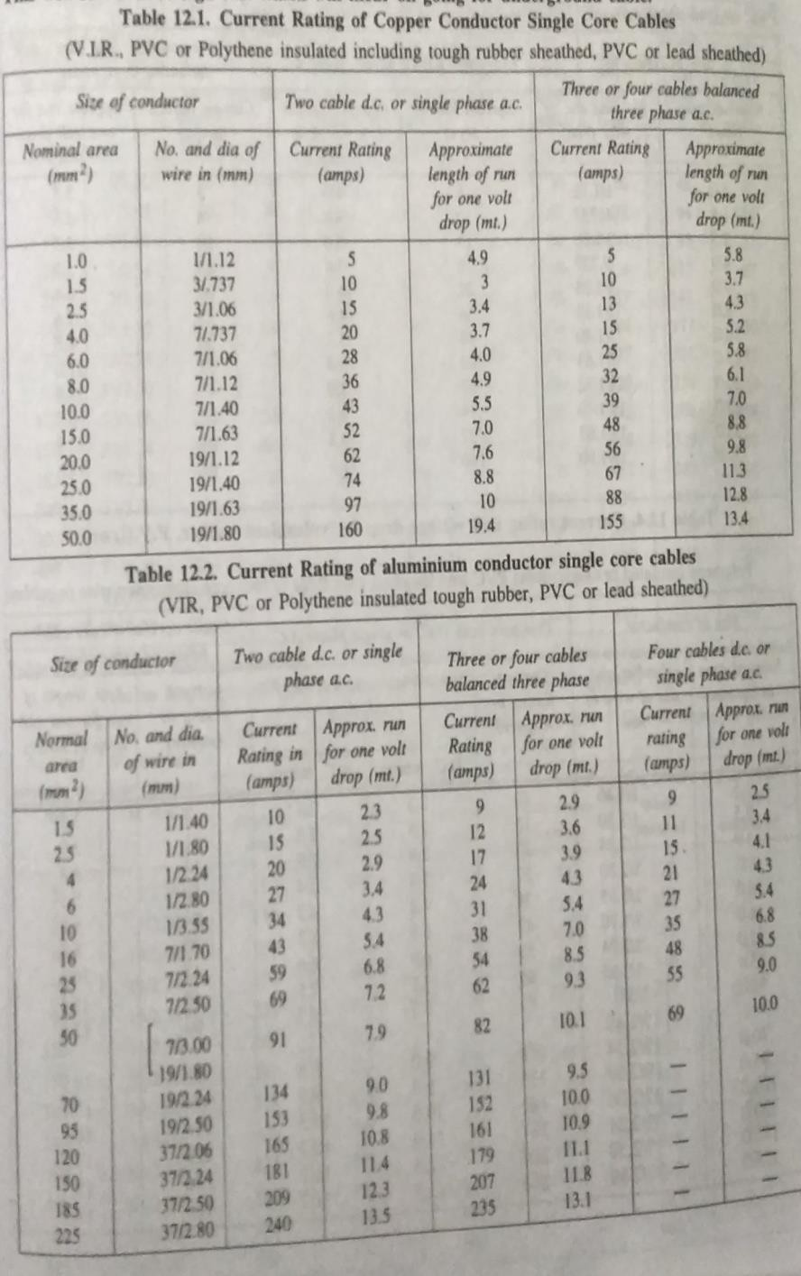

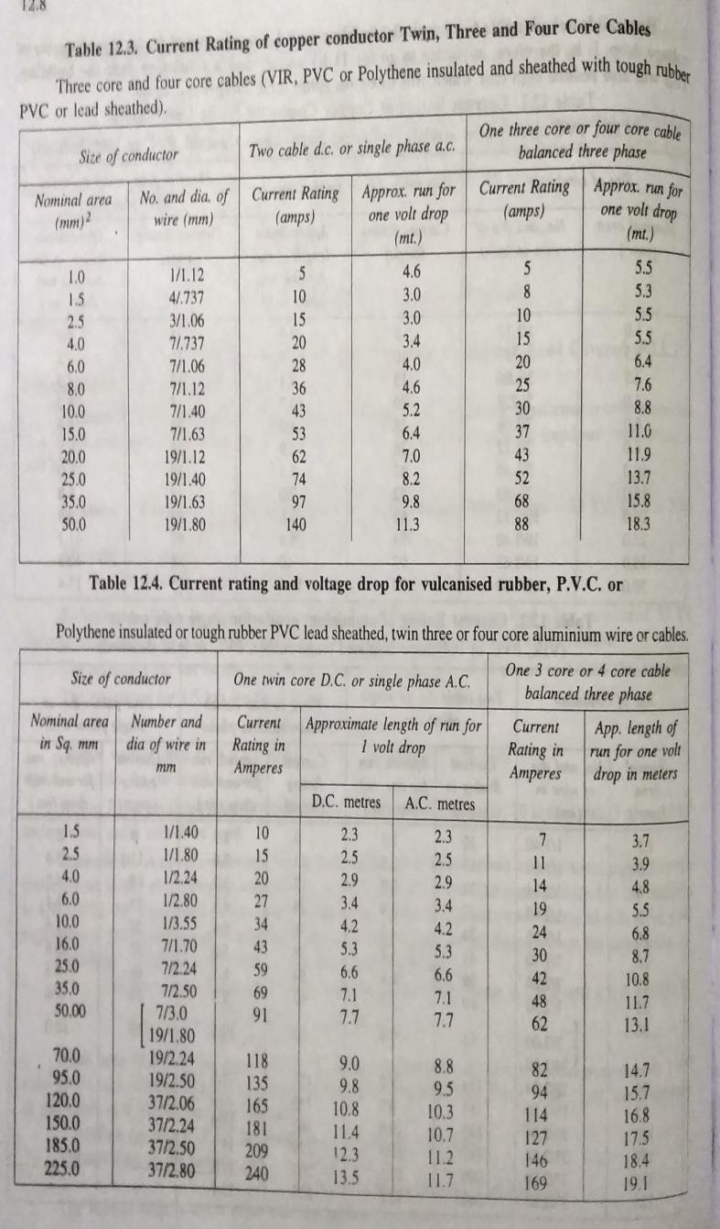

Selection of size of conduit---

The selection of conduit pipes depends upon no of cables of different sizes that are to be accommodated.
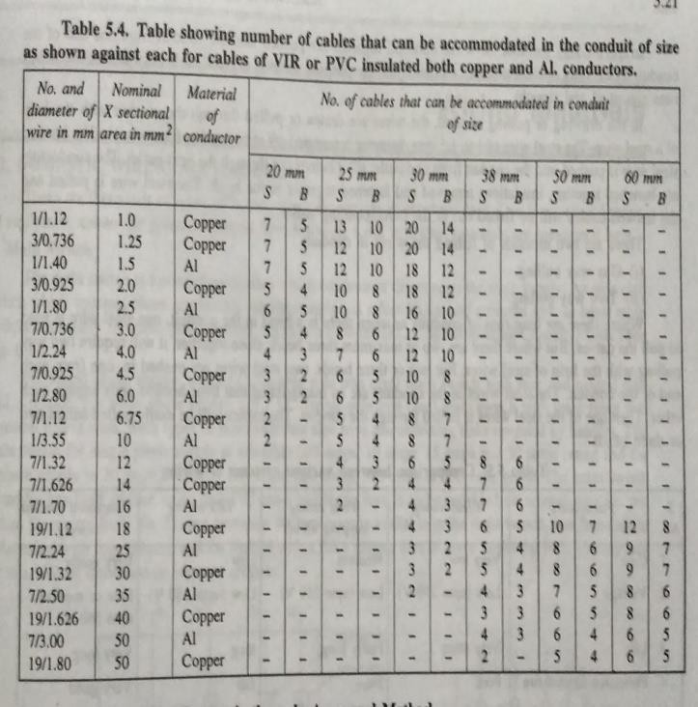
Selection & rating of main switch—

Selection of main switch is depends upon starting current of motor Selection & rating of distribution board—
It depends upon no of ckts (for motors & other loads )

PROBLEM-1

Prepare estimates & material table to install a power connection of 3-phase 5 HP induction motor for an agriculture tube well in the room size 3m× 3m× 3m .the motor is 1 m away from two nearest walls.

- Electrical wiring plan
- Single line diagram ,showing earth wires also.
- Decide the rating & specification of important materials and calculate the length of wire,conduit,earth wire & prepare a complete list of materials required .

Ans-
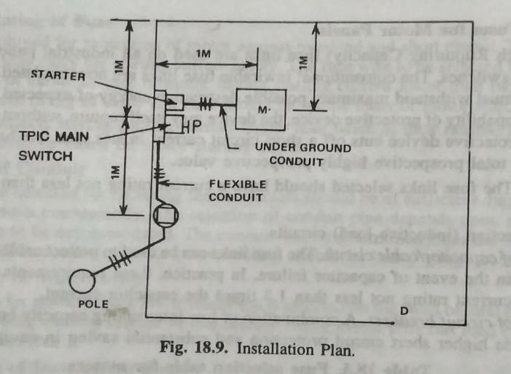
Assumption-

  - Height of main board from floor =1.5m
  - Two earth wires enclosed of 15mm dia G.I pipe
  - Motor is installed 0.25m above floor on a suitable foundation. full load current = 5×735.5 /(√3 ×p.f × voltage × efficiency)

=5×735.5 /(√3 ×0.85 × 400 ×0.75)

=8 amp SELECTION & RATING OF MS-
Assume total current drawn by motor = 8+ (50% of 8)=12 amp

It is very close to 16 amp, the next higher rating main switch 32 amp available in market. So specification is TPIC 32A ,500v grade MS.

SELECTION & RATING OF WIRE-

We refer above rating of cable table ,it suggested that pvc insulated Al conductor size 6mm² 0r 1/2.80 mm dia.

CALCULATION OF HEAVY GAUGE CONDUIT PIPE,25 MM DIA---

From main board to top of motor foundation=1.5 +0.25(depth of trench)+1.0(along trench)+0.25+0.25=3.25m
Total length of conduit = 3.25 +10% wastage =3.57m nearly say 4m

CALCULATION FOR LENGTH HEAVY GAUGE CONDUIT PIPE ,15mm DIA FOR EARTH WIRE---

From main board to top of motor foundation=3.25×2 pipe=6.5m For 10% wastage so, total length=6.5+0.6=7.1m or 7m
CALCULATION FOR LENGTH OF FLEXIBLE CONDUIT OF SIZE 25mm DIA ---

from energy meter to main board=1.0m from main switch to starter=0.5m
from starter to conduit mouth=0.25m

from motor foundation to motor terminal block=0.25m total length of flexible conduit=1.0+0.5+0.25+0.25=2m for 10% of wastage
so total is=2+0.2=2.2m say 2.5m

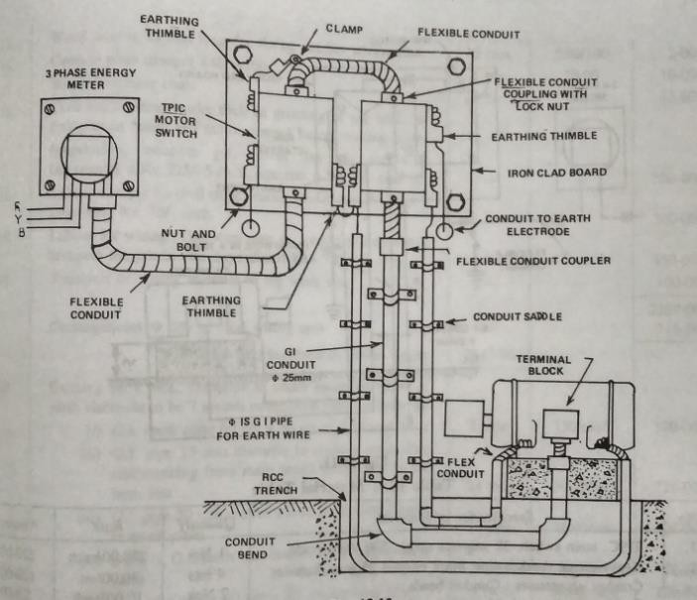

CALCULATION FOR LENGTH OF WIRE OF 6mm² or 2.80 mm DIA---

Conduit has 3 wires for 3-phase DOL starter,so

Toatal Length of wire =length of conduit (rigid+flexible)×3 wires

=(3.25+2.0) 3=15.75 +2.5m(15% wastage)=18.25 m say 19m CALCULATION FOR LENGTH OF 8SWG, G.I EARTH WIRE---
Length of earth wire= length of conduit×2wires

=3.25 ×2 wires=6.5 m+2m around main board

=8.5m =9m
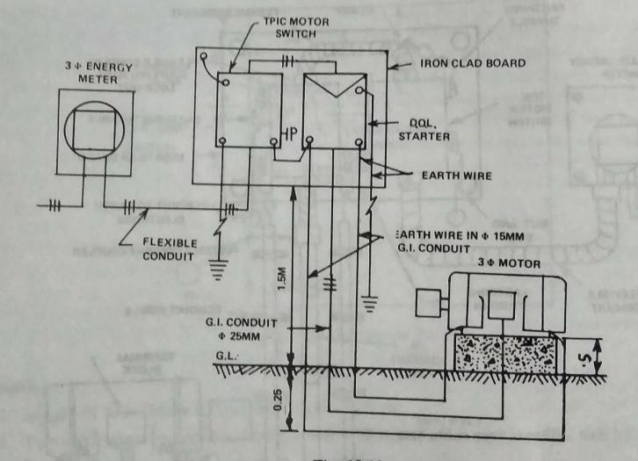

Material table—

Si no | Description | specification | Quantity
01 | Main switch (TPIC) | 32 amp,500v | 01 no
02 | Iron clad board fabricated with angle iron & MS sheet with fitting  accessories | 30cm×30cm | 1set
03 | Heavy gauge conduit pipe with it’s  fitting accessories | 25mm dia | 4m
04 | G.I conduit pipe with fitting  accessories | 15 mm dia | 7m
05 | Flexible conduit pipe with it’s  fitting accessories | 25mm dia | 2.5m
06 | Pvc insulated Al conductor | Single core, 6mm² or 1/  2.80 mm dia | 18m
07 | Earth wire with it’s fitting  accessories | G.I type 8swg | 9m
08 | MS sheet fix with wall fitting  accessories | --- | 1 set
09 | Conduit bend ,saddle | --- | As per required
10 | Danger plate | 440v | 01
11 | Sundries to complete the whole job | ---- | As per required

DOMESTIC WIRING—

SEQUENCE TO BE FOLLOWED IN CARRYING OUT THE ESTIMATE---

- Drawing installation plan
- Calculation for total connected load in amperes
- Selection & rating of main switch and sub main switch 4- Selection of main distribution board
- Calculation for conduit pipe or batten
- Calculation of length of phase & neutral wire 7- Calculation of length of earth wire
- Preparing material table ARRANGEMENT OF APPARATUS-
Energy meter--- to--- DPIC main switch-----to---- main DB----to---subcircuits (switch board)

- Every sub circuit contains light,fan, & 5-amp socket loads

- each sub circuit is having not exceeding 10 no of points or 800 watts

SELECTION OF WIRE—

It depends upon specified load in ckt which considered as

  - Insulated wire for mechanical reason
  - Voltage drop
  - Current carrying capacity
  - Types of insulation is used i.e VIR ,pvc, TRS etc
  - Grade i.e 250v, 500v, 660v etc (6)

PROBLEM-2

A room & a varandah, the plan of to be provided with electrical wiring. Mark the location of energy meter,main switch & switch board & electrical points suitable & draw the installation plan showing supply path to each point & wiring diagram. Calculate the total length of wire required for wiring the room & varandah in batten system of wiring .prepare a list of materials with complete specification of each item .

Ans-
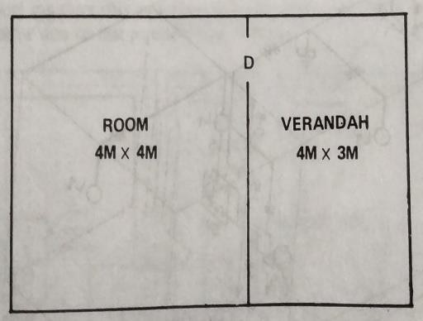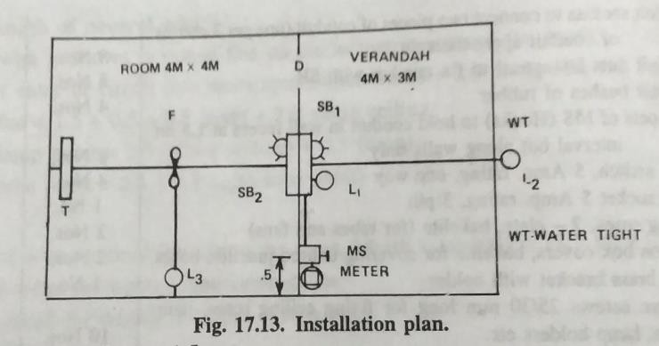

From this plan we required

- Room contain –two light points, one fan & 5 amp socket load
- Varandah contain –two light points, 5 amp socket load

ASSUMPTION-

    - Total height of ceiling =3.5m
    - Height of HR from floor =3.0m
    - Height of SB from floor =1.5m

    - Location of energy meter & main switch board =0.5 m inside varandah on room wall.
    - All dimension in meter Calculation of load-
Lamps= 3×60=180w

Fan= 1×60=60w

Socket outlet 5amp= 2×100=200w Fluorescent tube= 1×40=40w
- -

Total load= 480w

Load in amp = watt/volt=480/230=2.1amp

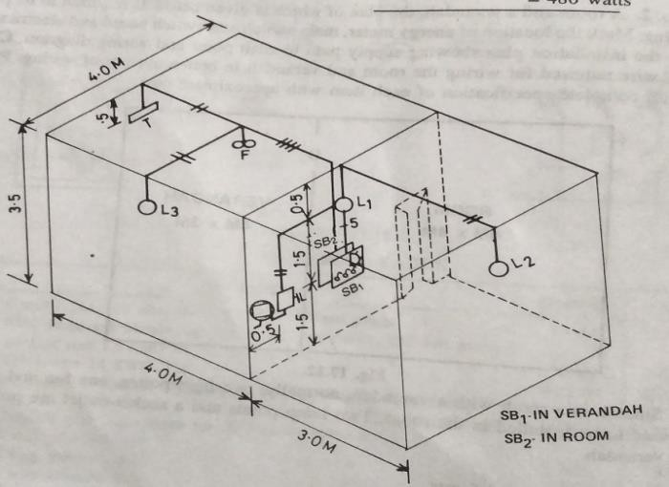

SELECTION & RATING OF MAIN SWITH—

D.P.I.C Main switch of 5 amp rating 250 v grade is selected SELECTION & RATING OF DB—
Total points are 7points, so no distribution board is required.

CALCULATION FOR LENGTH OF BATTEN---

From main board to L₁—(13mm×13mm) 2wires =1.5+1.5=3m L₁ to SB₁ --(31mm×13mm) 5wires =1.5m
L₁ to L₂ --(13mm×13mm) 2 wires =0.5+3+0.5=4m SB₂ to fan ---(25mm×13mm) 4 wires =2+2=4m
Fan to L₃ ---(13mm×13mm) 2 wires =2+0.5=2.5m Fan to tube point --- (13mm×13mm) 2 wires =2.5 m

TOTAL LENGTH OF BATTEN OF SIZE---

13mm×13mm = 3+4+2.5+2.5=12m+(10% wastage)=13.2m=13m

25mm×13mm = 4m +((10% wastage)= 4.4m=4.5m 31mm×13mm =1.5m+(10% wastage)=1.6m=2m
CALCULATIONS OF LENGTH OF AL CONDUCTOR VIR WIRE OF SIZE 1.5mmsq—

Length of wire calculated from length of batten of various sizes 13mm×13mm = 12m × 2wires = 24m
25mm×13mm = 4m× 4wires= 16m 31mm×13mm =1.5m× 5wires=7.5m
-

Total length of wires on batten = 47.5m

Total length of wires = 47.5m + 1m (wall crossing) +15% wastage =55.7 m says 56m CALCULATION OF LENGTH OF EARTH WIRE OF SIZE 14 SWG GALVANISED STEEL---
From MS –to-SB₂ through SB₁ = 1.5+1.5+1.5+0.25= 4.75 m

Total length= 4.75 +0.47= 5.2m say 5m

Material table—

Si no | Description | specification | Quantity
01 | DPIC main switch | 5amp, 250v grade | 01
02 | Teak wood main box for enclosing MS & DB | 30cm× 30 cm | 01
03 | Teak wood batten size | 13mm×13mm 25mm×13mm  31mm×13mm | 13m 4.5m  2m
04 | VIR Al conductor | 1.5mmsq ,250v grade | 56m
05 | Earth wire | 14 SWG ,G.I type | 5m
06 | Conduit pipe for wall crossing | 20mm dia | 0.25m
07 | Switch board with fitting accessories | 20cm×10cm  20cm×25cm | 01 no  01no
08 | Flush switch | 5amp, one way | 06 no
09 | Socket | 5amp, 3-pin | 02 no
10 | Ceiling rose | 2 plate, backlite | 02 no
11 | Teak wood round block | 10mm dia | 04no
12 | Teak wood plugs (gutties)at 0.75 m interval | ----- | 30 no
13 | Holder | --- | 02no
14 | Link clips ,aluminium 40mm long (one clip on two  wires 10cm apart (length of wire+2×10 clips) | ---- | 300 no or 3  boxes
15 | Wood screws 25mm long to fix batten with gutties at  0.75 m interval | ---- | 30no
16 | Wood screws 15mm long | ---- | 15 nos
17 | Sundries to complete the whole jobs | ---- | As per  required

PROBLEM-3

A room & a varandah, the plan of to be provided with electrical wiring. Mark the location of energy meter,main switch & switch board & electrical points suitable & draw the installation plan showing supply path to each point & wiring diagram. Calculate the total length of wire required for wiring the room & varandah in conduit wiring .prepare a list of materials with complete specification of each item .

Ans

From this plan we required

- Room contain –two light points, one fan & 5 amp socket load
- Varandah contain –two light points, 5 amp socket load

ASSUMPTION-

    - Total height of ceiling =3.5m
    - Height of HR from floor =3.0m
    - Height of SB from floor =1.5m
    - Location of energy meter & main switch board =0.5 m inside varandah on room wall.
    - All dimension in meter Calculation of load-
Lamps= 3×60=180w

Fan= 1×60=60w

Socket outlet 5amp= 2×100=200w Fluorescent tube= 1×40=40w
- -

Total load= 480w

Load in amp = watt/volt=480/230=2.1amp

SELECTION & RATING OF MAIN SWITH—

D.P.I.C Main switch of 5 amp rating 250 v grade is selected SELECTION & RATING OF DB—
Total points are 7points, so no distribution board is required.

CALCULATION FOR LENGTH OF conduit pipe 25mm dia--- From main board to L₁— =1.5+1.5=3m
L₁ to SB₁ -- =1.5m

L₁ to L₂ -- =0.5+3+0.5=4m

SB₂ to fan --- =2+2=4m

Fan to L₃ --- =2+0.5=2.5m

Fan to tube point --- =2.5 m

TOTAL LENGTH OF CONDUIT PIPE=3+1.5+4+4+2.5+2.5=17.5+(10% wastage)=19.2m say 20m CALCULATIONS OF LENGTH OF PHASE WIRE—
From main board to L₁— =1.5+1.5=3m

L₁ to SB₁ -- =1.5m×3 wire=4.5M

L₁ to L₂ -- =0.5+3+0.5=4m

SB₂ to fan --- =2+2=4m×3wire=12M

Fan to L₃ --- =2+0.5=2.5m

Fan to tube point --- =2.5 m

Total length of phase wire=3+4.5+4+12+2.5+2.5=28.5+0.25(wall crossing)+(10% wastage)=32.3m say 32.5m

CALCULATIONS OF LENGTH OF NEUTRAL WIRE—

From main board to L₁— =1.5+1.5=3m

L₁ to SB₁ -- =1.5m×2wire=3.0M

L₁ to L₂ -- =0.5+3+0.5=4m

SB₂ to fan --- =2+2=4m=4M

Fan to L₃ --- =2+0.5=2.5m

Fan to tube point --- =2.5 m

Total length neutral wire=3+3+4+4+2.5+2.5=19+0.25(wall crossing)+(10% wastage)=21 CALCULATION OF LENGTH OF EARTH WIRE OF SIZE 14 SWG GALVANISED STEEL---
From MS –to-SB₂ through SB₁ = 1.5+1.5+1.5+0.25= 4.75 m

Total length= 4.75 +0.47= 5.2m say 5m Material table—
Si no | Description | Specification | Quantity
01 | DPIC main switch | 5amp, 250v grade | 01
02 | Phase wire | 1.5mmsq ,250v grade | 32.5m
03 | Neutral wire | 1.5mmsq ,250v grade | 21m
04 | Earth wire | 14 SWG ,G.I type | 5m
05 | Conduit pipe | 25mm dia | 20m
06 | Switch board with fitting accessories | 20cm×10cm  20cm×25cm | 01 no  01no
07 | Flush switch | 5amp, one way | 06 no
08 | Socket | 5amp, 3-pin | 02 no
09 | Ceiling rose | 2 plate, backlite | 02 no
10 | Conduit pipe accessories for 25 mm dia 1 way junction box  3 way junction box | --- | 03 no  01 no
11 | Conduit bend | --- | 06 no
12 | Holder | --- | 02no
13 | Conduit socket accessories | --- | As per  required
14 | Crampets of MS hooks to hold conuit in wall at 1.5m  interval |  | 11 no
15 | Sundries to complete the whole jobs | ---- | As per  required

Problem-4

The plan of two room ,one varandah office building is given below, the building is required to be provided with electrical conduit wiring at 230 v single phase, suggest electrical points suitable in rooms & varandah.solve the estimate in the following sequence.

- Installation plan on the plan of building starting from energy meter
- Wiring diagram

- Calculate the total materials
- Prepare the list of materials ASSUMPTION-
- Total height of ceiling =3.5m
- Height of HR from floor =3.0m
- Height of SB from floor =1.5m
- Location of energy meter & main switch board =0.5 m inside varandah on room wall.
- All dimension in meter

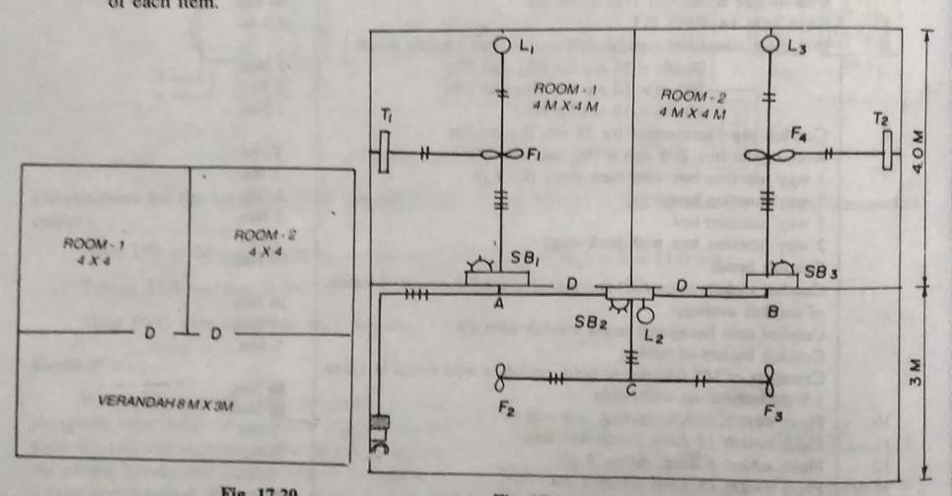

CALCULATION KOF LOADS-

Lamps = 3×60=180w

Fans = 4×60=240w

Fluorescent tube= 2×40=80w Socket 5amp = 3×100=300w
-

Total load = 800w Current in amp = watt/volt =800/230=3.5 amp SELECTION & RATING OF MAIN SWITCH---
DPIC main switch 15 amp rating,250v grade is selected

SELECTION & RATING OF DISTRBUTION BOARD---

There are 12 points so two sub ckts are selected Sub circuit 1 points controlled from SB₁
Sub circuits2---- points controlled from SB₂ & SB₃

It is suggested that a two way MCB ,each 5 amp rating alongwith double pole MCB with neutral link should be used.
CALCULATION OF LENGTH OF CONDUIT PIPE OF 25MM DIA—

Main board to L₂ = 1.5+2.5+4= 8m L₂ to junction ‘c’ =0.5+1.5 =2m
‘c’ to fan 2 = 2m

c’ to fan 3 =2m

L₂ to SB₂ =1.5m

L₂ to HR above SB₃ =2m SB₃ to fan4 =1.5+0.5+2=4m
Fan4 to tube light 2 =2+0.5= 2.5m Fan4 to L₃ =2+0.5=2.5m
SB₁ to fan 1 =1.5+0.5+2=4m

Fan 1 to L₁ =2+0.5=2.5m

Fan1 to tube light 1(T₁) =2+0.5=2.5m

- -

Total length =35.5 m

Total length of pipe = 35.5 + (0.25+0.25) wall crossing+10% of wastge=39.6 say 40m CALCULATION PHASE WIRE---
Main board to junction A = 1.5+2.5+2= 6m×2wire=12m Junction A to L₂ =2m
L₂ to junction ‘c’ =0.5+1.5 =2m×2wire = 4m

‘c’ to fan 2  c’ to fan 3 |  | = 2m  =2m
L₂ to SB₂ | =1.5m×4wire | =6m
L₂ to junction B |  | =2m

SB₃ to HR above the SB₃ =1.5m×4wire=6m HR above the SB₃ to fan 4 =0.5+2=2.5m×3wire=7.5m
Fan4 to tube light 2 | =2+0.5 |  | = 2.5m
Fan4 to L₃ | =2+0.5 |  | =2.5m
SB₁ to HR above SB₁ |  | =1.5m×4wire | =6m

HR above SB₁ to fan1 =0.5+2=2.5m×3wire =7.5m Fan 1 to L₁ =2+0.5 =2.5m
Fan1 to tube light 1(T₁) =2+0.5 =2.5m

- -

Total length = 67m

Total phase wire = 67+(0.25+0.25) wall crossing+10% wastage= 74m CALCULATION OF NEUTRAL WIRE—
Total length of neutral wire= length of conduit pipe=36m+10% wastage=39.6=40m CALCULATION FOR LENGTH OF EARTH WIRE OF SIZE 14 SWG OF GALVANISED STEEL---
From MB to SB₃= 1.5+2.5+6+0.25(wall thickness)+1.5=11.75m From HR to SB₁ =0.25 +1.5=1.75m
From HR to SB₂ = 1.5m

Total length of earth wire= 11.75+1.5+1.5=15m+10% wastage=16.5m=17m

MATERIAL TABLE—

Si no | Description | Specification | Quantity
01 | DPIC main switch | 15 amp, 250v grade | 01
02 | Phase wire | 1.5mmsq ,250v grade | 74m
03 | Neutral wire | 1.5mmsq ,250v grade | 40m
04 | Earth wire | 14 SWG ,G.I type | 17m
05 | Conduit pipe | 25mm dia | 40m
06 | Switch board with fitting accessories SB₁  SB₂ & SB₃ | 30cm×30cm 20cm×25cm | 01 no 02no
07 | Flush switch | 5amp, one way | 11 no
08 | Socket | 5amp, 3-pin | 03 no
09 | Ceiling rose | 2 plate, backlite | 06 no
10 | Conduit pipe accessories for 25 mm dia 1 way junction box  - way junction box  - way junction box | --- | - no  - no  02no
11 | Conduit bend | --- | 06 no
12 | Holder | --- | 03no
13 | Conduit socket accessories | --- | As per  required
14 | Crampets of MS hooks to hold conuit in wall at 1.5m  interval |  | 27 no
15 | Sundries to complete the whole jobs | ---- | As per  required

Short questions- workshop
Q.1-what is the maximum load that can be connected in a power sub ckts. Ans- the maximum load that can be connected in a power sub ckts is 3000w Q.2-what is the maximum no of outlet that can be connected in power sub ckt Ans-2
  - –what is minimum size of alluminimum size that can used for wiring of a power ckt Ans—2.5 mm dia

Q.4- what type of starter can be used for 5 kw 1-φ I.M Ans- push botton DOL starter
Q.5- what type starter you recomoddated for a 20 kw squirrel cage I.M Ans- auto transfer starter
Domestic

Q.6- according to rural electrification (RE) & I.E rules each ckt contains how many points & power rating Ans-800 watt
Q.7-what is the size of batten for for carrying 10 single core cable Ans- (63mm×13mm)
Q.8-what is permissible voltage of internal house wiring- Ans- +/- 2%
Q.9- what is full form of PILC

Ans- pvc insulated line conductor

Q.10- why fuse is not provided on neutral of AC supply

Ans- neutral wire is the returning path of AC, in case of any fault ,the heavy fault current passes through the electrical apparatus before melt of fuse,so apparatus are damaged.

Q.11-what is the full form of AAC,ACSR,TRS,VIR Ans- - AAC- all aluminium conductor
ACSR- aluminium conductor steel rainforced TRS- tough rubber sheath
VIR-vulcanised indian rubber

Q.12-why concealed conduit wiring is not suitable on workshop-

Ans- in this wiring fault finding & repairing is very difficult so concealed conduit wiring is not suitable on workshop
Q.13- what is full form of CTS Ans- CTS- cab type sheathed

Long questions— Workshop -
Q.1-Estimate the list of materials required for connecting a 20 HP ,3-phase,50HZ squirrel cage I.M as an irrigation pump from exiting main switch in the pump house 6m distance.

Q.2-list out materials required to provide internal connection with small workshop having a work floor of 4m×6m & consist of

    - A 415 v,3-phase,10kw welding T/F

    - a 230v I.M operated lathe m/c

- 230 v 50HZ 1.5 HP bench grinder
- Provide required fan & light point

Q.3 a 37kw connection is to be given to an agriculture field at 415v, 3-phase ,50hz . the connection is to be given from a 3-phase 11kv O.H distribution line which is at a distance of 40m. The motor has a full load efficiency of 85% & p.f 0.8 .make a neat sketch & estimate the quantity of material required.

Domestic wiring

Q.4-discuss conduit type of wiring briefly

Q.5 -estimate the material required to provide internal wiring for a building whose plan (8m×3m)size of floor is having room size (4m×3m) & varandah (4m×3m),using conduit wiring . draw electrical wiring diagram & preapare list of material

Q.6- what are the different types of wiring explain about conduit system of wiring

Q.7 - estimate the material required to provide internal wiring for a building whose plan given below , use batten wiring , draw electrical wiring & prepare list of materials
